**Kailasanathar Temple: Website Contents**

1. **Introduction and Significance**

The Rajasimhesvara temple, now known as the Kailasanathar Temple is the oldest surviving temple in the city of Kanchipuram. Constructed in the early 8th century AD by the renowned Pallava king Rajasimha, after whom it was originally named, the temple is celebrated for its architectural elegance and rich sculptures. It served as the main source of inspiration for the Chalukyan temple of Virupaksha at Pattadakkal and the celebrated Kailasa temple of Ellora. Unlike many other temples in the Tamil region, it has largely remained unaltered over time, preserving early sculptures, inscriptions in ancient scripts, and original architectural forms. Set against a typical South Indian scenery of green paddy fields and coconut groves, the Rajasimhesvara Temple is the loveliest of all the temples in the ancient city of Kanchi.

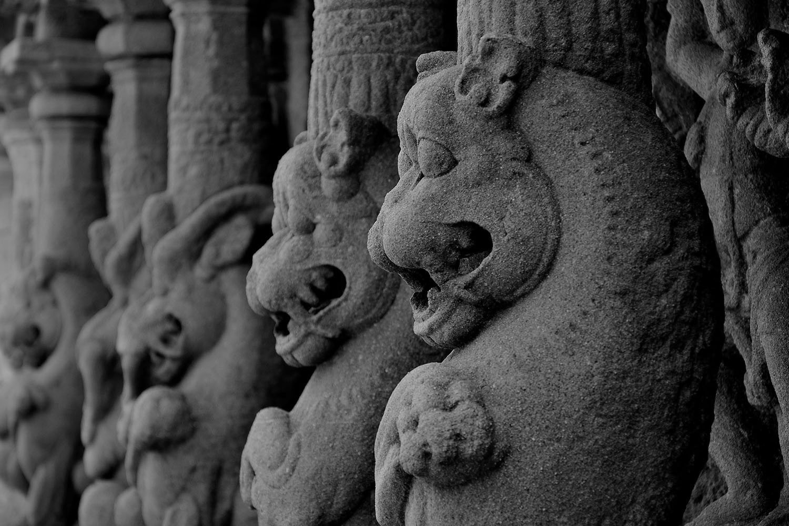

Lion Sculptures at the Temple (Source: Akshatha A, Friends of Heritage Sites, Tamil Nadu)

**Contextual Significance - The City of Kanchi:** Kanchipuram, once considered the most beautiful city in ancient India, holds a prestigious place in history. An ancient saying even declares, "Among cities, Kanchi ranks first." Long before the rise of Madras in the 18th century, Kanchi was the most prominent city in northern Tamil Nadu. It has a rich history, predating even Emperor Ashoka, who is believed to have erected a stupa here. Tamil classics from the Sangam era (3rd century B.C. to 2nd century A.D.) provide vivid descriptions of the city's glory. The Pallavas, known for their love of arts and letters, made Kanchi their capital by about 275 A.D. It continued to be the seat of their power for nearly six hundred years till 875 A.D. Over these centuries, Kanchipuram became a vibrant centre of religious, cultural, and political activity, with its built fabric being dotted with more than 150 temples dedicated to Lord Shiva and Lord Vishnu.

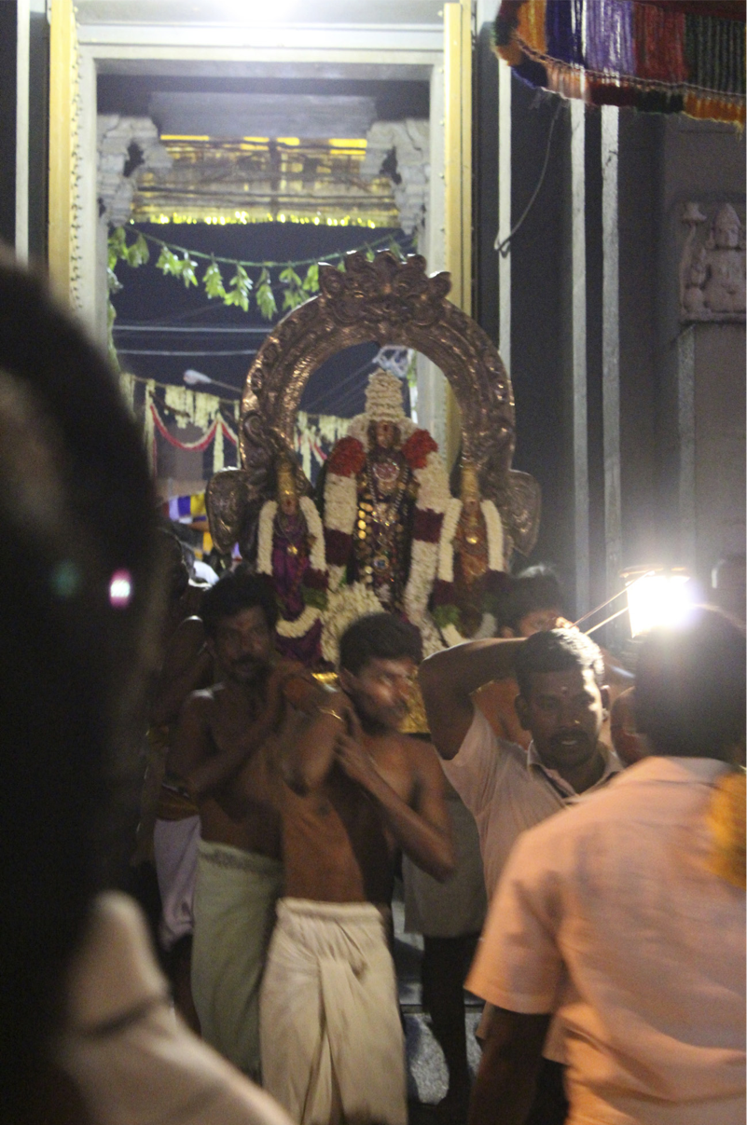

Kanchi – The Sacred City (Source: Stein, Emma Natalya, 2015)

'

**Artistic and Architectural Significance:**  The Kailasanathar temple exhibits the creative genius of the Pallava architects in design and scale of construction. The sculptors outscored everyone when provided with a large surface area, by way of conceptualizing and carving many new forms of divine imagery for the first time in the history of south India.  The fact that the sculptors did not have any model to follow to create this array of divine imagery makes the temple an outstanding example of a first-of-its-kind experimentation in temple architecture. This combination of architectural knowledge and the sculptural sensitivity resulted in the creation of some of this edifice, which still occupies an exalted position in the development of temple architecture in India.

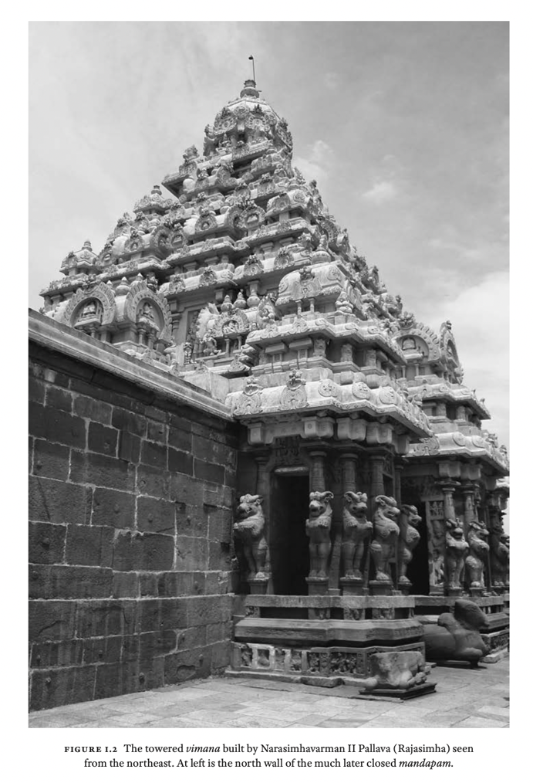

View of the Temple Vimana (Source: Kaimal, 2020)

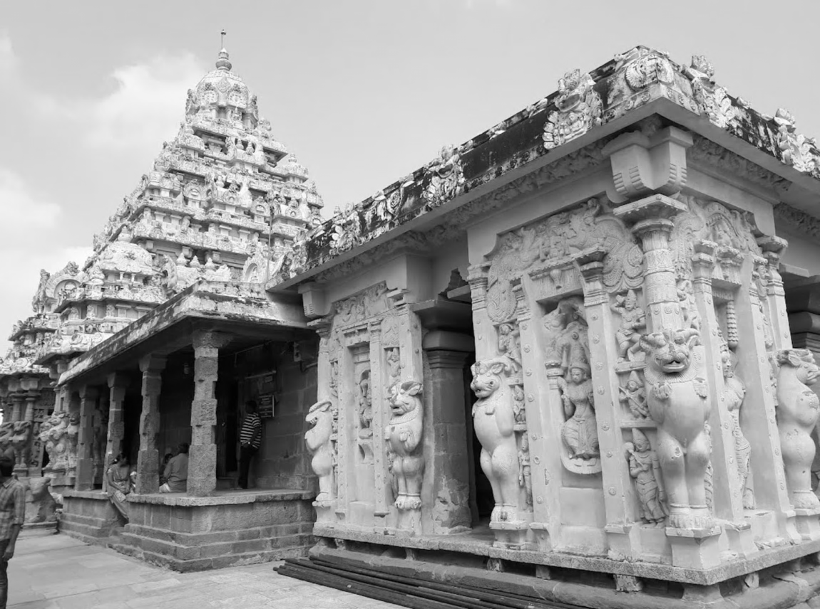

**Historical Significance:** The Kailasanathar Temple is a significant monument of early South Indian temple architecture, built under the patronage of the Pallava dynasty. This temple marks a critical transition from earlier rock-cut cave temples to free-standing stone structures, showcasing the Pallavas' architectural innovation and ambition. As one of the earliest examples of South Indian temple architecture, it features a towering vimana, intricate sculptures, and detailed inscriptions, preserving early Shaivite iconography. The temple also reflects the Pallavas’ political power, serving as a symbol of their imperial authority. The Kailasanathar Temple not only influenced subsequent temple architecture in South India, including the grand Chola temples, but also contributed to Kanchipuram's status as a major religious and cultural centre for centuries.

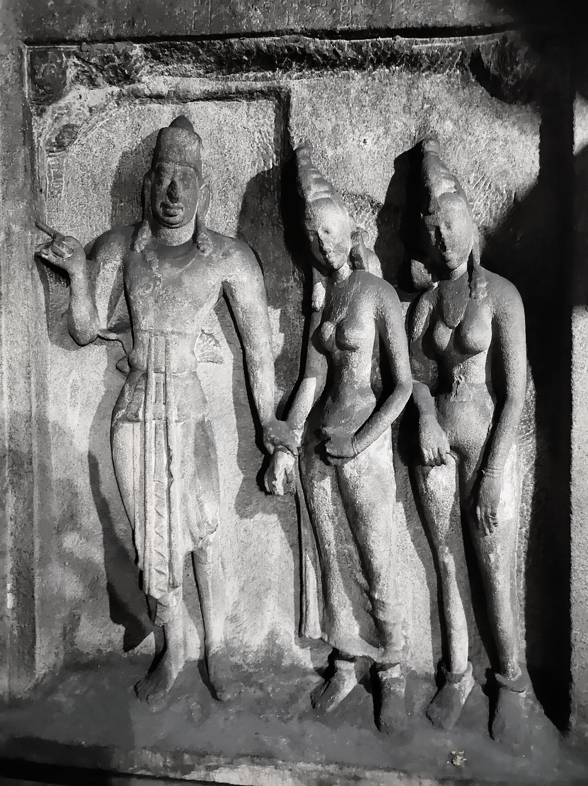

Pallava King Mahendravarman I at Adivaraha Cave Temple, Mahabalipuram (Source: Wikimedia Commons)

**Spiritual/Religious Significance:** The Kailasanathar Temple, is more than an architectural marvel—it embodies profound spiritual significance. The temple’s intricate design and artistic elements reflect deep philosophical ideas related to samsara, or the cycle of existence. Through its sculptures, architecture, paintings, and inscriptions, the temple conveys two key dimensions of life: one focused on nurturing and abundance, and the other on overcoming external and internal challenges. These energies are not presented as opposites like purity versus pollution or male versus female, but rather as complementary forces, symbolizing the Pallavas' efforts to sustain their lineage and emulate the divine actions of gods and goddesses, all while seeking to restore cosmic harmony.

The temple’s spiritual essence is closely tied to Shaiva Siddhanta, a school of Shaivism that, in the eighth century, included esoteric and transgressive rituals now classified as Tantra. These practices aimed to transcend conventional boundaries and explore deeper spiritual truths. The Kailasanathar Temple, in this context, serves as a sacred space where these complex ideas of existence and divine energy are held in balance, offering insights into both the seen and unseen dimensions of spiritual practice in ancient India.

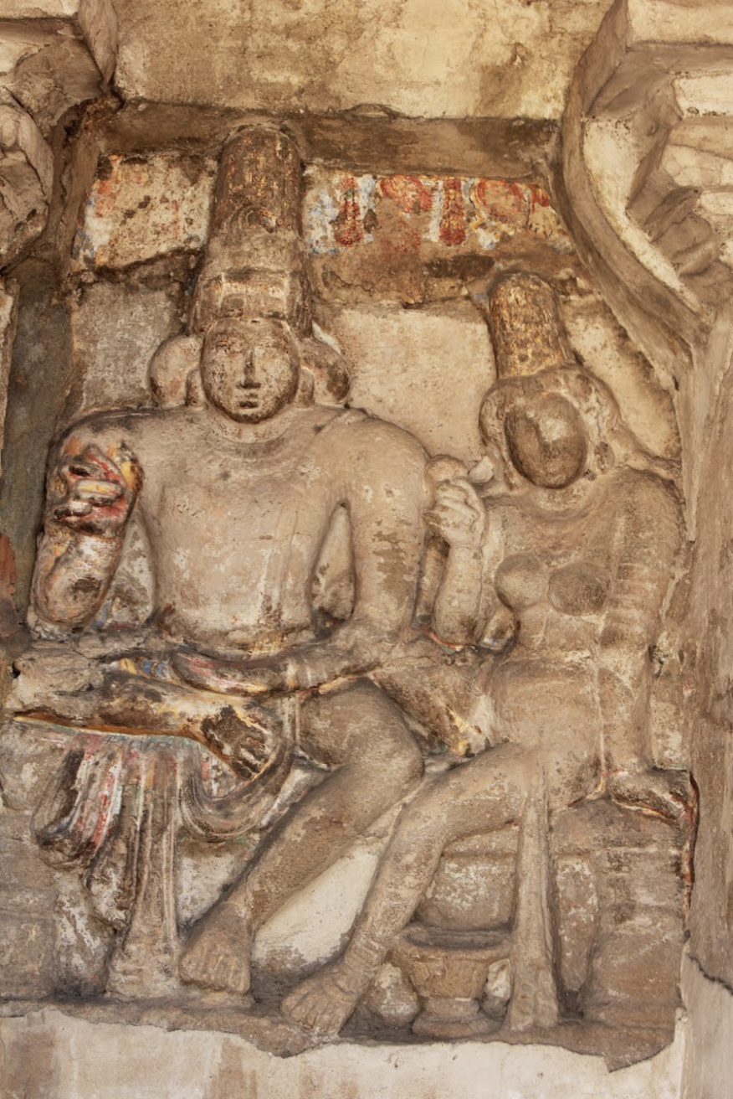

Shiva and Uma at Kailasanathar (Source: Akshatha A, Friends of Heritage Sites, Tamil Nadu)

**Communal Significance:** The Kailasanathar Temple in Kanchipuram holds deep communal significance, being one of the earliest and most revered Shaivite temples in South India. Dedicated to Lord Shiva, the temple became a pivotal center for Shaiva Siddhanta philosophy, embodying both spiritual devotion and complex metaphysical ideas. The temple’s communal role extended beyond religious worship; it served as a cultural hub where art, music, and learning flourished, fostering a strong sense of identity among its followers. Over centuries, it became a pilgrimage destination, drawing worshippers from across the region, and continues to play an essential role in the religious life of Kanchipuram.

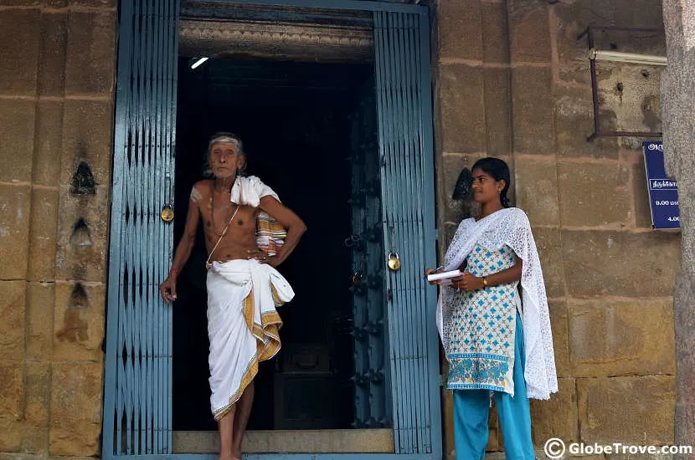

Communal Values of the Temple

1. **Historical Background**

The Pallavas, originally feudatories of the Andhra Satavahanas, gained independence after the decline of Satavahana power. Initially ruling Palnadu in Andhra Pradesh, they expanded into Tamil regions, establishing their capital at Kanchipuram around the 4th century AD. Their dynasty reached its peak during the reigns of Mahendravarman I (571–630 AD) and Narasimhavarman I (630–668 AD).

Narasimhavarman II, known as Rajasimha (700–728 AD), in the early years of his rule, commissioned the Kailasanathar Temple. According to an inscription at the Kailasanathar temple, his birth is likened to the divine birth of Subrahmanya (Kumara) from Lord Shiva. Rajasimha was highly devout, particularly devoted to Lord Shiva, and followed the Saiva doctrine to purify himself of ignorance. He was a patron of the arts and architecture, as demonstrated by the monuments he left at various locations such as Kanchi, Mamallapuram, and Panamalai, earning him the title "Kalasamudra" (Ocean of Arts).

The Pallava period in South India marked a pivotal transition from Buddhist to Hindu traditions. The Pallavas' patronage of religious structures thus occurred during a time of spiritual revival, with Tamil poet-saints fostering temple traditions. Drawing from Buddhist influences, the Kailasanathar Temple incorporated elements like the vimana (tower), gopuram (gateway), and monolithic structures like those in Mahabalipuram, which blended different styles to symbolize unity between architectural traditions. The gopura, modeled after the Buddhist chaitya and barrel vault, symbolized the radiant sun, aligning with the temple's sanctum. The temple’s garbhagriha (sanctum) houses the Shiva linga, and the relief of Somaskanda, linking the king with divine presence.

The Kailasanathar Temple thus represented a critical moment in the evolution of structural temple architecture in South India, and its influence on subsequent temple designs remains significant.

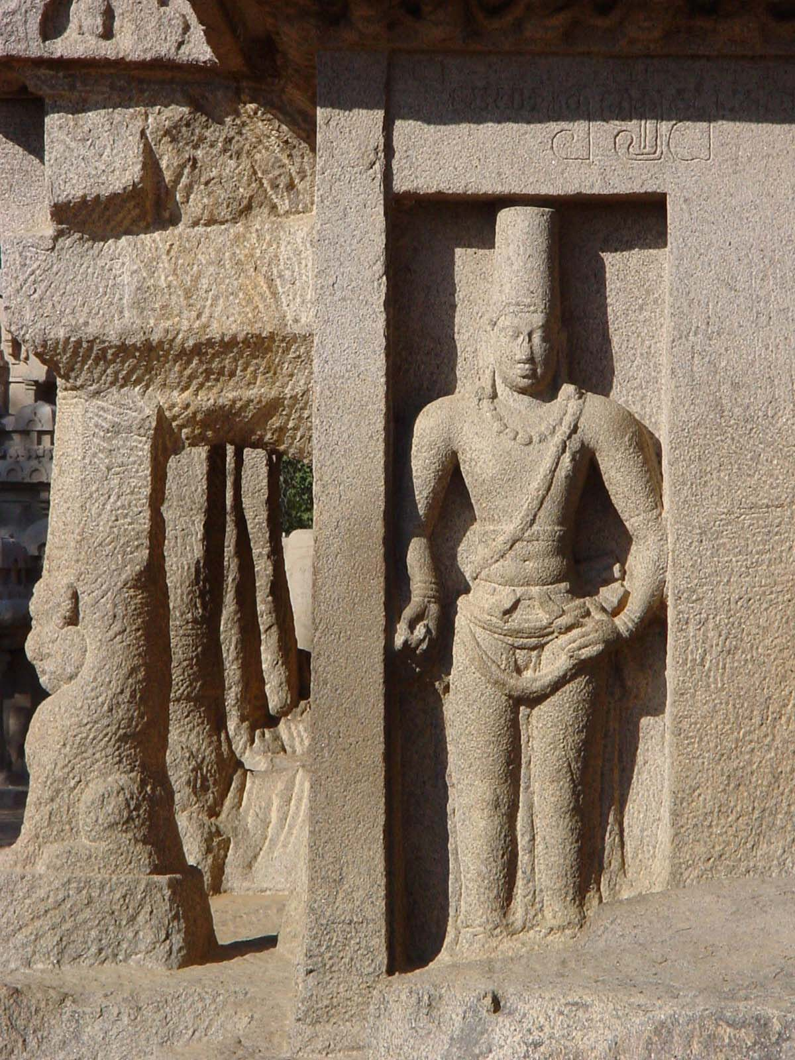

King Narasimhavarman I, at Dharmaraja Ratha (Source: Wikimedia Commons)

1. **Architectural Layout and Description**

The Kailasanathar temple was designed by the Pallava architects in a different plan and scale, unlike its forerunner the Shore Temple, Mamallapuram. It may be recalled that the Shore temple, also built by Rajasimha, is the first significant 'structural temple' of the Pallavas. It changed the paradigm as the time and resource consuming practice of excavating rock-cut temples and carving of monolithic temples were discarded or given up *in lieu* of easy to build structural temples. However, the architect opted for a softer, highly friable sandstone instead of the harder granite. Considering the weak load-bearing capacity of the chosen sandstone, he introduced a layer of hard granite at the floor level, indeed a genius idea.

The temple consists of the sanctum (v*imana),* and a detached *mandapa*of the Pallava period, now joined by a later period pillared hall.   Another independent shrine, contributed by his son Mahendravarman, was built axially in front, but in a smaller scale. Both the sanctums enshrine the signature Somaskanda panel on the rear wall with faceted linga (*dharalinga*) in the centre of the shrine. Another important aspect that was introduced was the passage for circumambulation (*pradakshinapatha*) around the sanctum.

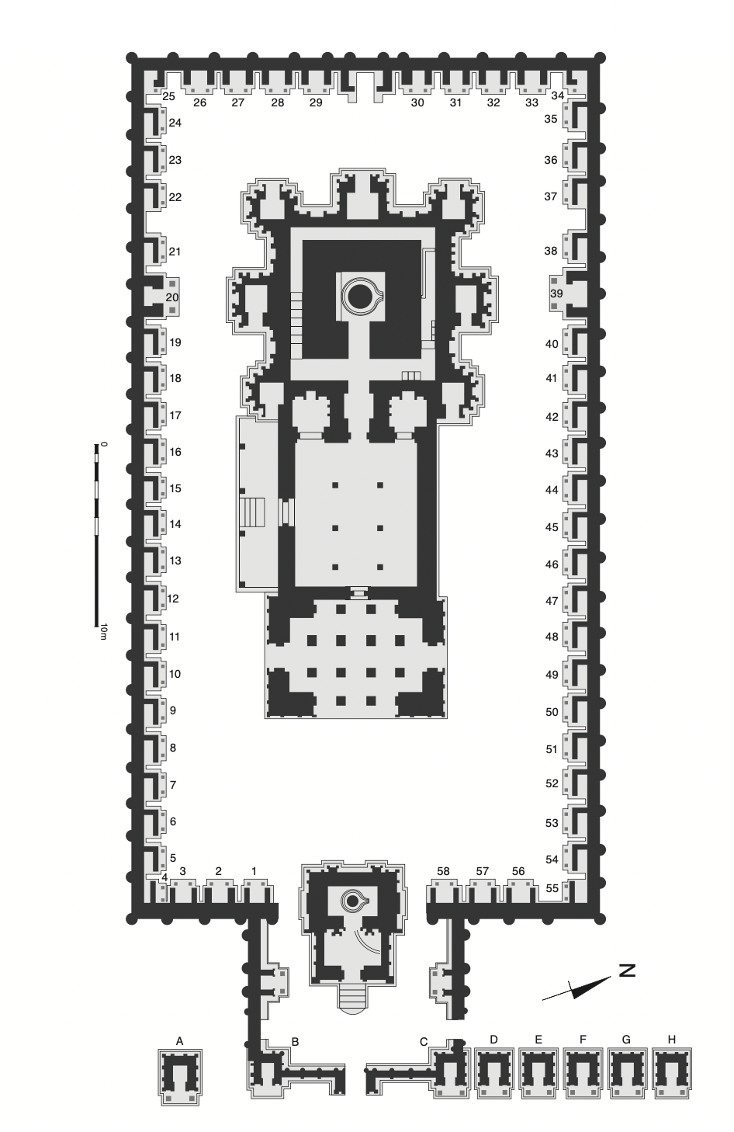

Ground plan of the Kailasanathar temple complex, showing the three central structures in the large courtyard, the cells surrounding the large courtyard, the temples of the eastern façade, and the oblong shrine behind them.

(Source: Mark R. Williams, from Kaimal, 2020)

# **The Nandi Mandapam:** The Nandi Mandapa in the Kailasanathar Temple, as described by scholars like K. R. Naraswamy and R. Nagaswamy, is a significant architectural feature that enhances the temple's spiritual and aesthetic dimensions. Currently Lion pillars have survived at the corners of the Nandi. Originally these pillars supported a mandapa, the superstructure of which has fallen. “Unlike the constricted temple interior and prakhara spaces, the great distance between the external Nandi Mandapa and the temple’s eastern entrance, as well as the once spacious eastern courtyard that surrounded Rajasimha’s mandapa before it was joined to the vimana, suggests that portions of the temple were designed to accommodate a large number of visitors.” Stein, Emma Natalya (Thesis - All Streets Lead to Temples: Mapping Monumental Histories in Kanchipuram, ca. 8th-12th centuries CE)

Nandi Mandapa

(Source: Wikimedia Commons)

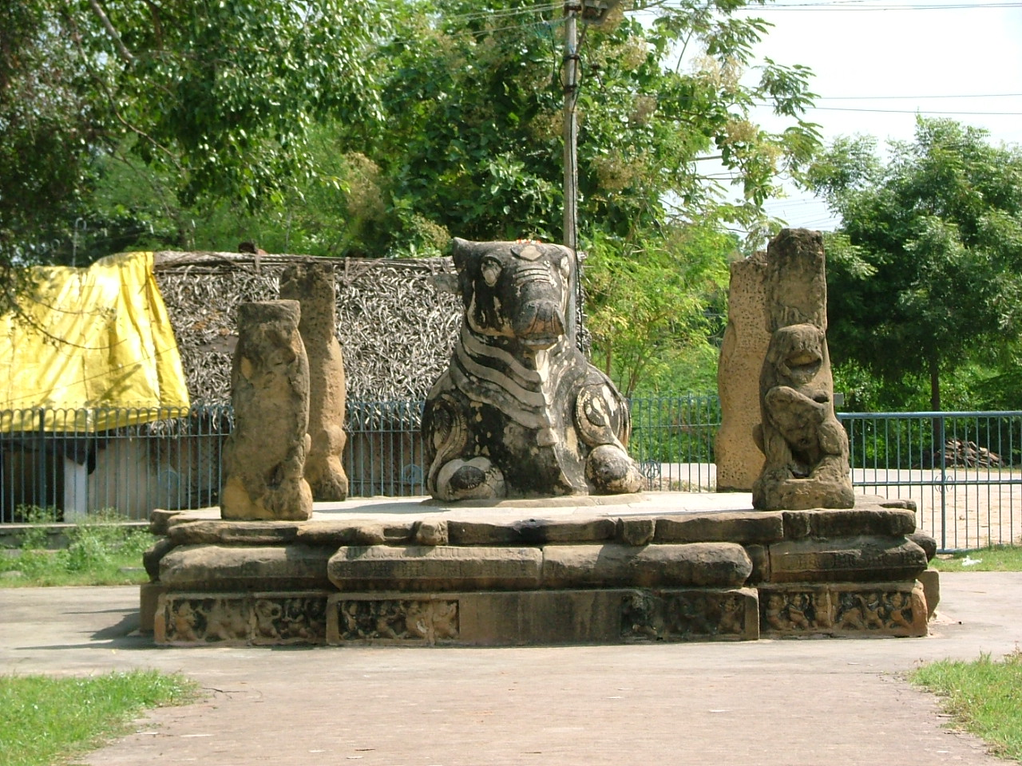

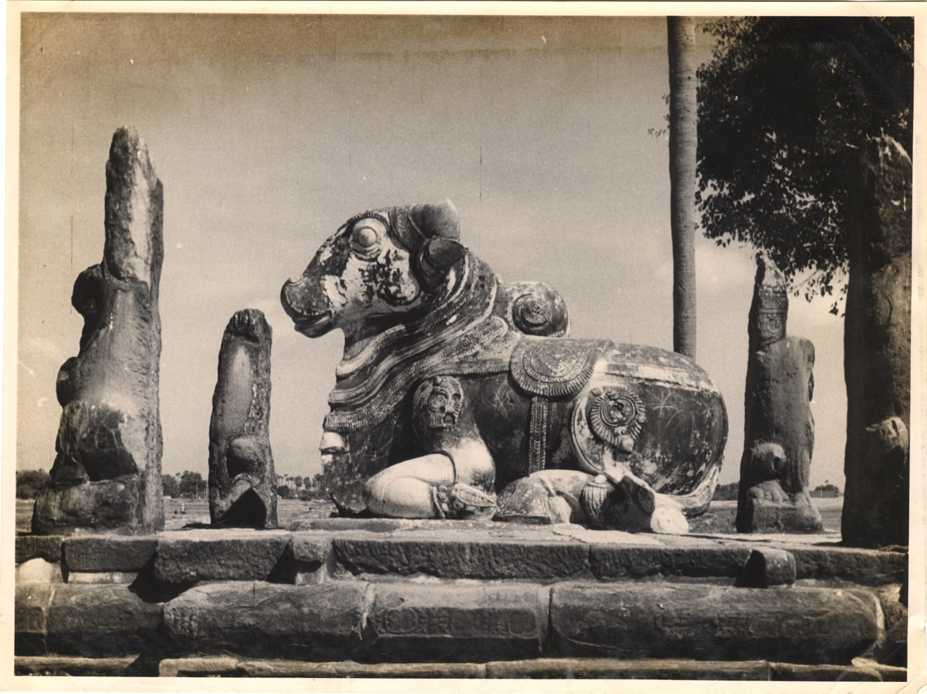

Nandi Mandapa Archival Photo

(Source: Archaeological Survey of India Archives)

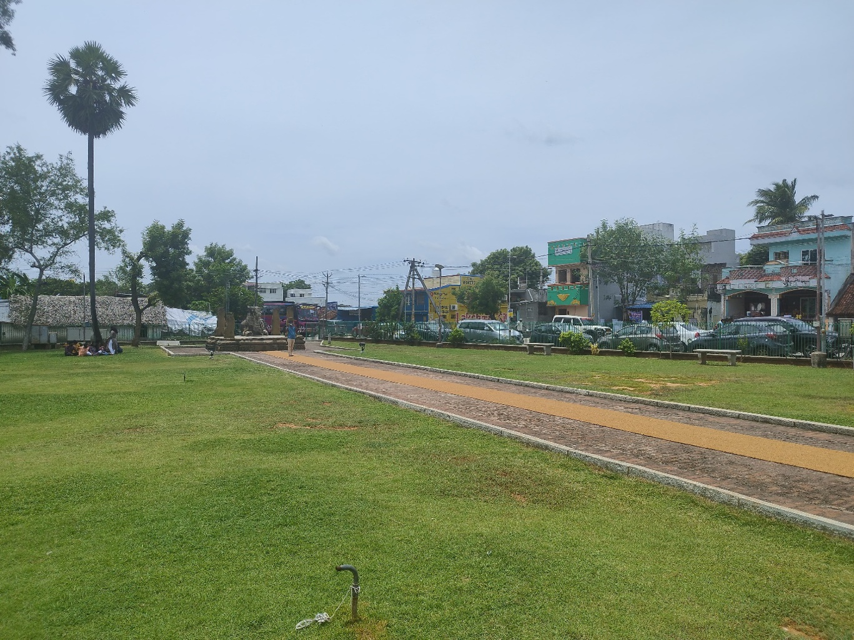

View of Nandi Mandapa from Temple Entrance

Source: Williams, Conservation Architect, DRONAH

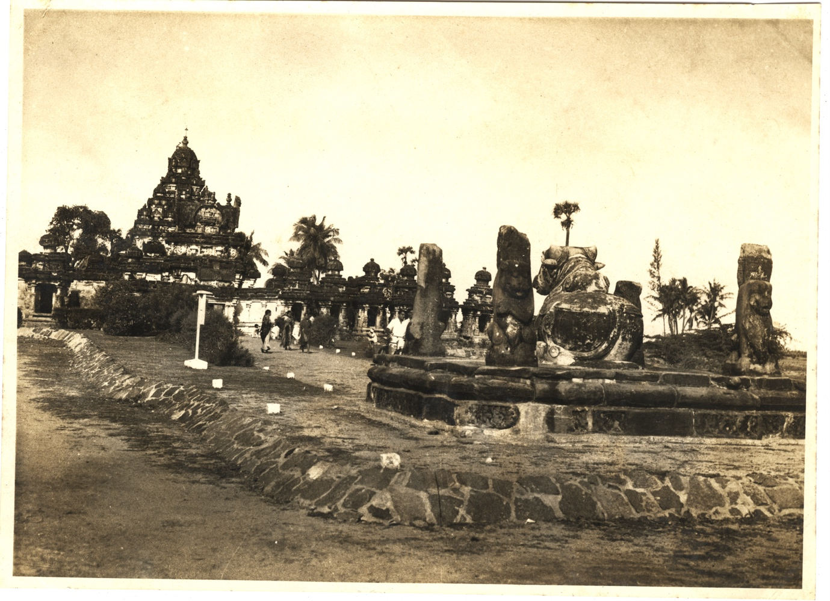

View of Nandi Mandapa and Main Shrine

(Source: Archaeological Survey of India Archives)

**The Main Shrine:** The main sanctum is accessed by a flight of steps on the southern side of the connecting mandapa. This mandapa contains several fragmentary inscriptions from the Chola period on its floor and ceiling. The sanctum faces east, and at its center stands Lord Rajasimhesvara in the form of a prismatic linga. This linga, made of highly polished granite with 16 facets, stands about three feet tall. Above the linga, on the back wall of the sanctum, is a Somaskanda panel. The main shrine is constructed with two walls—an inner wall encasing the sanctum and an outer wall, leaving a narrow passage in between. This dual-wall design was meant to ensure structural stability.

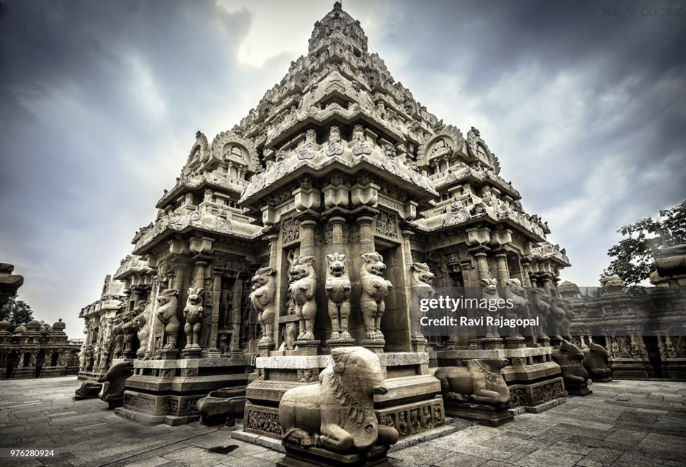

Main Shrine

<https://www.gettyimages.in/detail/photo/kailasanathar-temple-kanchipuram-india-royalty-free-image/976280924?adppopup=true> (Purchasable Image)

**The Main Vimana:** The *Vimana*—the main tower above the sanctum—rises with a graceful and imposing presence, adorned with rows of *salas* and *kutas* that encircle it like garlands. It is topped by an octagonal *shikhara*, similar to that of the Dharmarajaratha at Mamallapuram, and crowned by a stupa. This elegant tower became a prototype for later *vimanas* across the Tamil region. While earlier superstructures over sanctums were typically built with brick and mortar, this temple uniquely uses stone from base to top. When constructed, it was likely the tallest stone tower in Tamil Nadu, which earned it the title "great stone temple" (*periya thirukkarral*) in inscriptions.

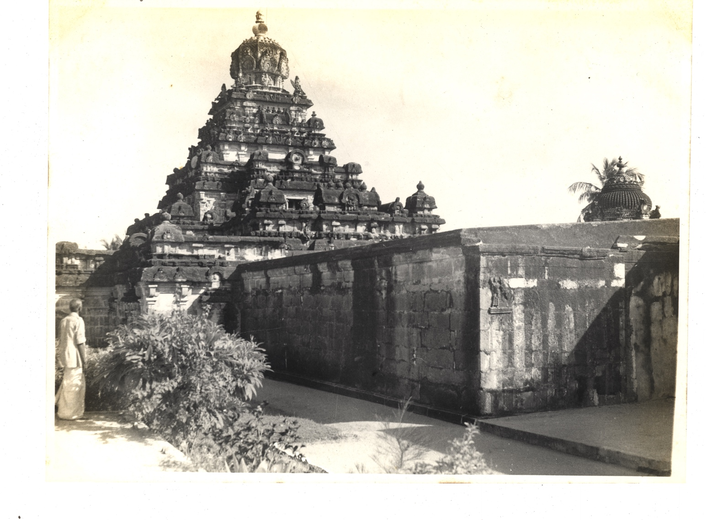

View of the Main Vimana

(Source: Archaeological Survey of India Archives)

**The Sub-Shrines:** The main shrine is accompanied by seven sub-shrines, known as *anga alayas* (limb shrines), located at seven corners. Three of these face west, while the other four face east. The sub-shrines at the southeast and northeast corners feature sculptures of Shiva performing the Samhara Tandava dance, with Devi, as Bhavani, observing on one side, and ganas (attendants) playing musical instruments on the other. The sub-shrines to the north and south depict Somaskanda inside the shrine, with Shiva flanked by Brahma and Vishnu on the back wall, and Uma and Skanda on the side walls. A vigorous depiction of Nandi is seen on the south wall.

Among the three sub-shrines at the rear, the northwest one houses a large image of Bhikshatana Shiva, accompanied by the wives of rishis. The central rear shrine holds an image of Gangadhara, and the northeast shrine features an image of Tripurantaka.

The outer walls of both the main shrine and the sub-shrines are adorned with sculptures of various forms of Shiva and other deities. These include depictions of Shiva as Gauriprasada, Dakshinamurti, Lingodhbhava, Vinadhara, Urdhvatandava, and Harihara, as well as figures of Saraswati, Lakshmi, Jyeshta, and Katyayani.

The basement, decorated with elaborate moldings, features a row of Bhutaganas at the bottom, shown dancing joyfully while wielding weapons. The intricate expressions on the faces of these tiny figures reveal the exceptional skill of the artists.

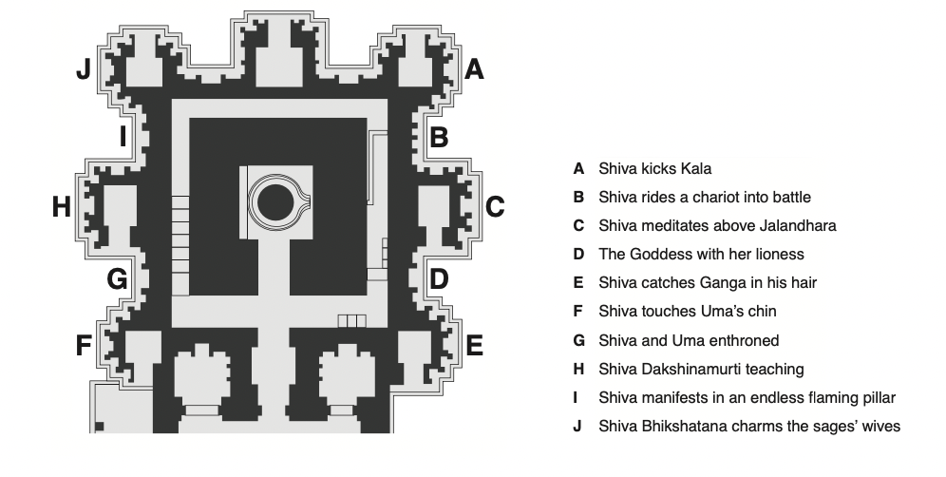

Main Shrine and Sub-Shrines Plan

(Source: Mark R. Williams, from Kaimal, 2020)

**The Front Mandapa:** The front *mandapa*, supported by plain pillars, is of the same age as the main temple. The corner walls of this mandapa feature sculptures, though they are now heavily plastered over. The pillars bear numerous inscriptions dating from the 8th to the 16th century AD. One of the earliest inscriptions in the mandapa is of great historical significance. It is written in Kannada script and was engraved by order of the Chalukya king, Vikramaditya I, who likely captured Kanchi within a decade of the temple’s construction. Vikramaditya sought to avenge the defeat of his ancestors by the Pallavas, who were ruled at the time by Nandivarman Pallavamalla.

After capturing Kanchi, Vikramaditya was so captivated by the beauty of this great temple that he made an offering of gold to it. The Kannada inscription records this generous gift by the Chalukya ruler. Vikramaditya also took some of Kanchi’s finest artisans back to his kingdom at Pattadakkal, where, under the direction of his queen Lokamadevi, the Virupaksha Temple was constructed. This temple bears many resemblances to the Kailasanatha temple.

Front Mandapa

Source: Williams, Conservation Architect, DRONAH

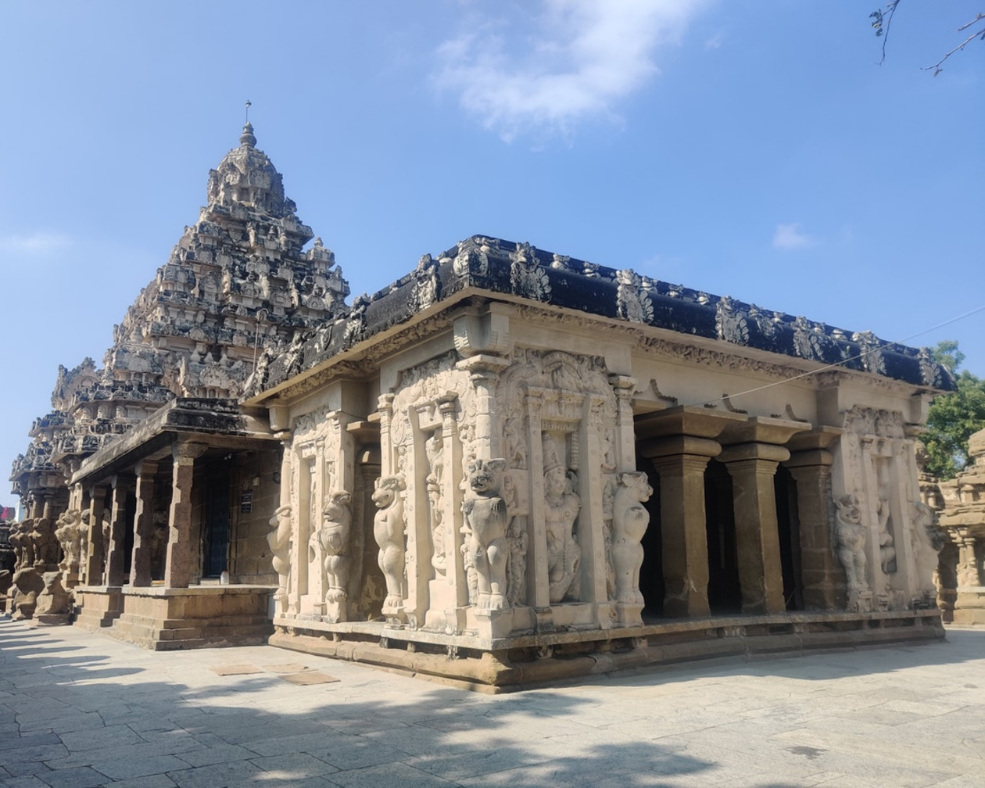

Front Mandapa

Source: Akshatha A, Friends of Heritage Sites, Tamil Nadu) Front Mandapa

Source: Williams, Conservation Architect, DRONAH

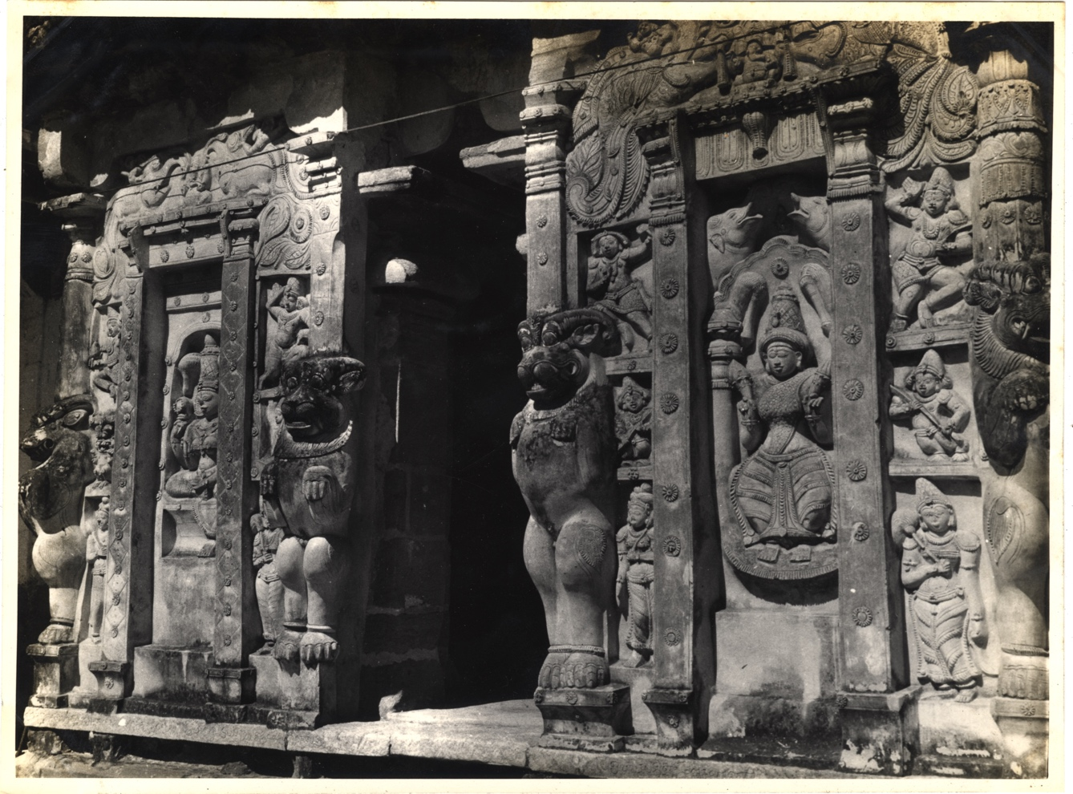

Front Mandapa

(Source: Archaeological Survey of India Archives)

**The Front Temple:** At the entrance of the temple enclosure stands a smaller temple, accessed by a flight of steps leading to the sanctum. This temple was built by Mahendra Varman III, the son of Rajasimha, and was constructed at the same time as the main temple. An inscription in Sanskrit, in Grantha script, on the temple’s basement records its construction. On the parapets of the steps, label inscriptions name the temple as Mahendravarmesvaragrham, or the Shiva temple of Mahendravarman.

In the center of the sanctum, Shiva is enshrined in the form of a fluted linga. A Somaskanda sculpture adorns the back wall of the sanctum. On the south wall of the front hall, there is an impressive eight-foot-tall image of Shiva in the Bhikshatana form. The northern wall features a dynamic depiction of Shiva performing the Samhara Tandava, the dance of destruction.

The shrine is surrounded by enclosure walls on the east, south, and north. These walls are adorned with sculptures of deities, all facing the inner shrine.

**The Temple Tank (Towards North-East corner of the Temple Compound):** Dr. V. Ganapathy Sthapathi (Padma Bhushan Dr V Ganapati Sthapati was a [master architect](https://www.hinduismtoday.com/magazine/january-february-march-2012/2012-01-obituary-honoring-a-master-architect-who-changed-the-landscape-of-india/) who began his career as a mathematics teacher but eventually founded the Vastu Vedic Trust to embark on a remarkable journey as a temple architect. He is rightly hailed as the doyen Shilpacharya of Bharat.) emphasizes the temple tank’s essential role as a sacred space for ritualistic purposes. In Hindu temples, the water in the tanks is often considered sacred, and the tank at Kailasanathar Temple reflects this ancient tradition. The author points out that the stepped design, an architectural hallmark of such tanks, was both practical and symbolic. Devotees were meant to gradually descend into the water, symbolizing a purification process. The idea was not just physical cleansing but a metaphor for spiritual cleansing before proceeding to worship Lord Shiva in the main sanctum. The tank was designed to mirror the spiritual significance of water in Hindu cosmology, which signifies life, purity, and the cyclical nature of existence. This aligns with the concept of Shiva being the cosmic creator and destroyer.

View of shrine with tank in front at kailasanathar temple in Kanchipuram

Source: Wikimedia Commons

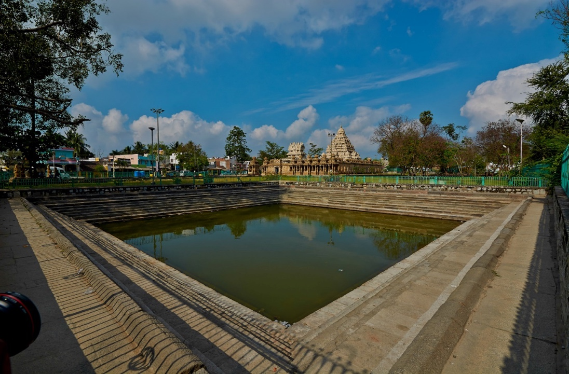

Temple Tank (Towards North-East corner of the Temple Compound)

Source: Williams, Conservation Architect, DRONAH

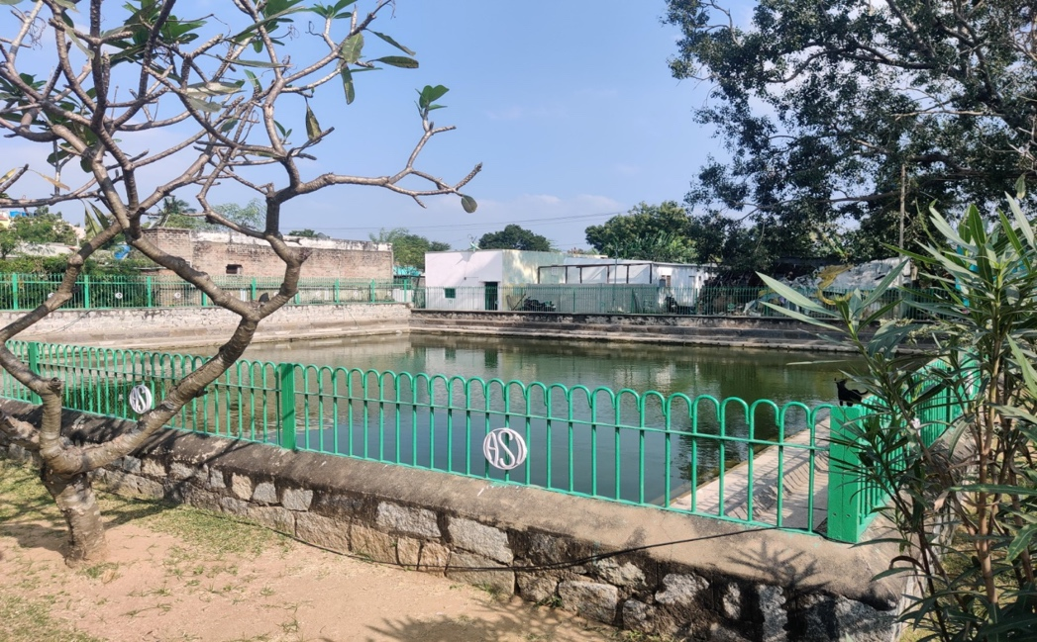

**The Enclosure:** The enclosure originally had entrances on both the east and west sides. The western entrance was later walled up and the eastern entrance was split into two passages due to the construction of the Mahendravarmesvara temple at its center. The enclosure walls are lined with a series of small square-shaped cell shrines that project from the back wall. These cell shrines rest on raised, ornamented basements and are preceded by a small pavilion-like structure supported by pillars adorned with seated lions or mythical creatures called Vyalas. Above these, towers rise, and between them, images of Nandi are seen on the walls. Elephants and lions are positioned at the four corners.

The shrine chambers on the east and west face inward toward the temple and feature Somaskanda panels on the back wall. Meanwhile, the cells along the south and north walls have shrine chambers that open to the east, though access is narrow. While the inner walls of these shrines lack sculptures, they were originally plastered and painted. It is believed that the Somaskanda motif was likely painted on the back wall of all the shrine chambers, with at least one instance of this painting surviving.

**Sandstone Well (South-East of Temple):** The sandstone well at the Kailasanathar Temple is an example of the architectural innovations of the Pallava dynasty, contributing to the understanding of water management practices in ancient South Indian temple architecture. This well, along with other water bodies in temple complexes, signifies the cultural emphasis on water as a sacred element in Hindu worship and daily life.

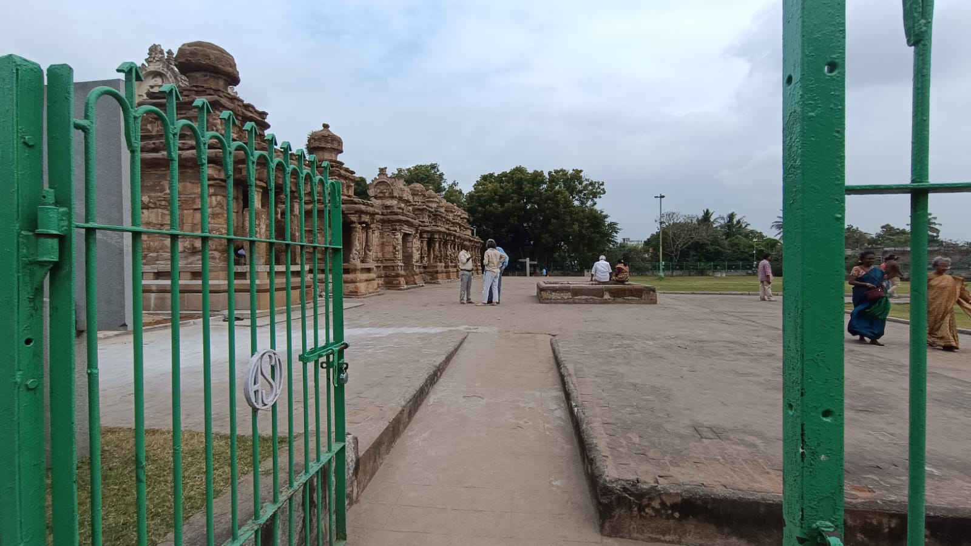

View of Sandstone Well from the present-day South Gate

Source: Williams, Conservation Architect, DRONAH

**The Outer Shrines:** Aligned with the entrance are eight small shrines arranged in a row—two to the south and six to the north. These miniature temples were built either by the king or his queens and share a similar design. All the shrines face east and are constructed on raised platforms of equal height, decorated with ornamental moldings. Each shrine consists of a sanctum chamber preceded by a porch, and inside the sanctums, Shiva is enshrined as prismatic lingas. On the back wall of each sanctum, Shiva is depicted with his consort, Uma, and their child Skanda, in the form known as Somaskanda Deva.

Aside from the eastern entrance, the other three sides of the shrines are adorned with sculptures depicting various aspects of Shiva, such as Somaskanda, Lingodhbhava, Kalari, Yogamurti, Samharatandava, Gajasamhara, Tripurasamhara, Dakshinamurti, Kshetrapala Samhara, and Urdhvatandava. These sculptures are of great interest. Originally, they were covered with a thin layer of plaster and painted. Over time, the sandstone used in constructing these shrines has weathered, and some of the final elements on the two-story shrines, including the *shikhara*, have fallen in some cases.

The shrine on the extreme south, the first upon entering, appears unfinished, as its carvings are incomplete. The shrine immediately to the north of the entrance bears an inscription labelling it as Nityavimtesvara Grha, or the Shiva temple of Nityavimta, a title of King Rajasimha. The third and fifth shrines on the north side were built by Rajasimha's queens, as indicated by their inscriptions. The fifth shrine was built by Rangapataka, Rajasimha's chief queen.

A small wagon-roofed ornament crowns the temple entrance. In the 8th century AD, entrance towers (*gopuras*) were relatively small, but over the centuries, they grew in significance and height, becoming the dominant feature of Tamil temple architecture today.

The entire plan of the main shrine with the subsidiary shrines and the miniature shrines along the *prakara*-wall indeed was intentional to create maximum surface area on its elevation.  This resulted in a veritable display of iconographically varied imagery of Brahmanical pantheon.

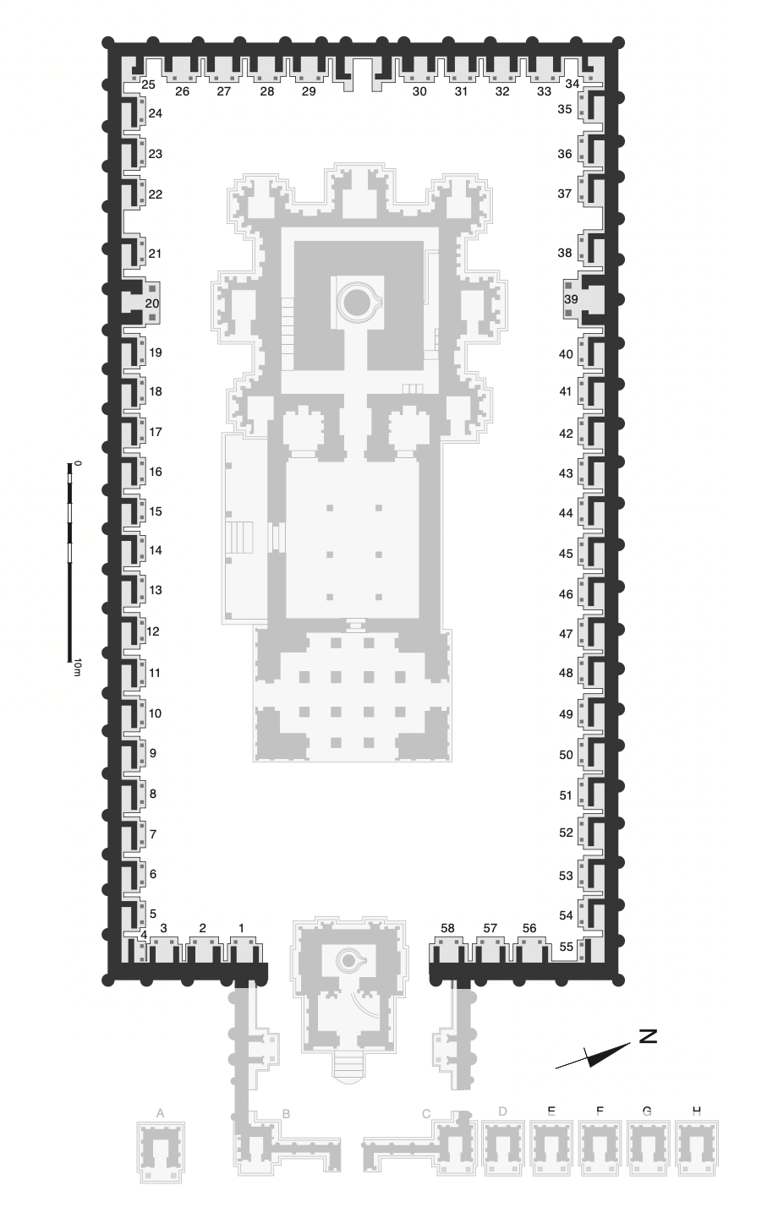

Emma Natalya Stein in her work All Streets Lead to Temples: Mapping Monumental Histories in Kanchipuram, ca. 8th-12th centuries CE calls these outer shrines as **‘Meditation Chambers’** and how these chambers’ special configuration enhanced acoustic reverberation during the process of meditation. All of these ‘Meditation Chambers’ open towards the east as seen in the following image of the temple plan.

Outer Shrines/Meditation Chambers with openings on the East Side

Source: Base Plan by Mark R. Williams, from Kaimal, 2020)

Outer Shrines

Source: Williams, Conservation Architect, DRONAH

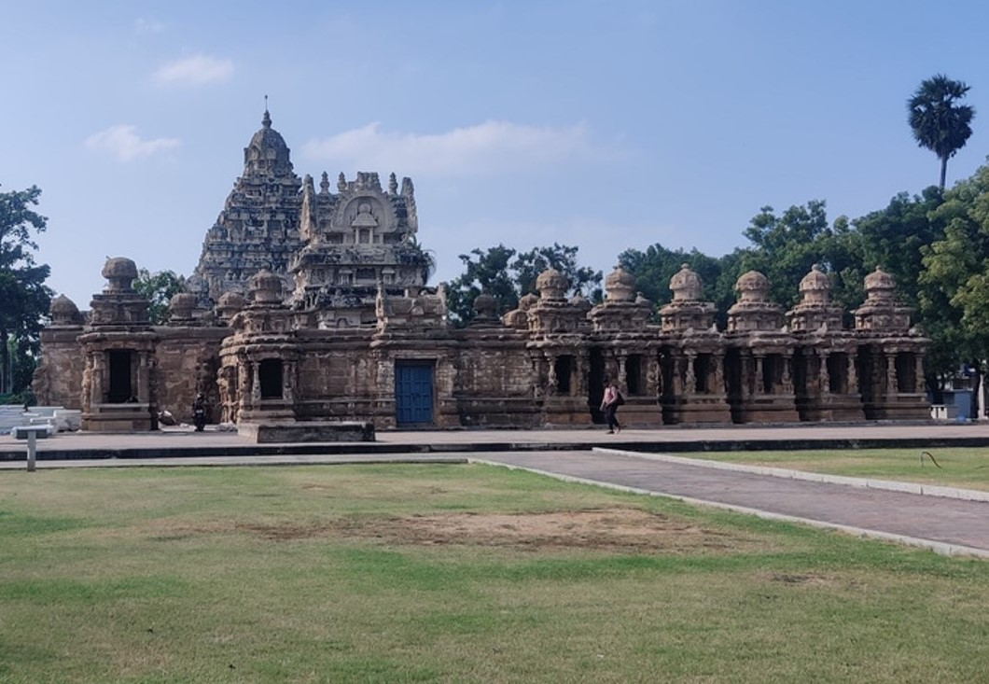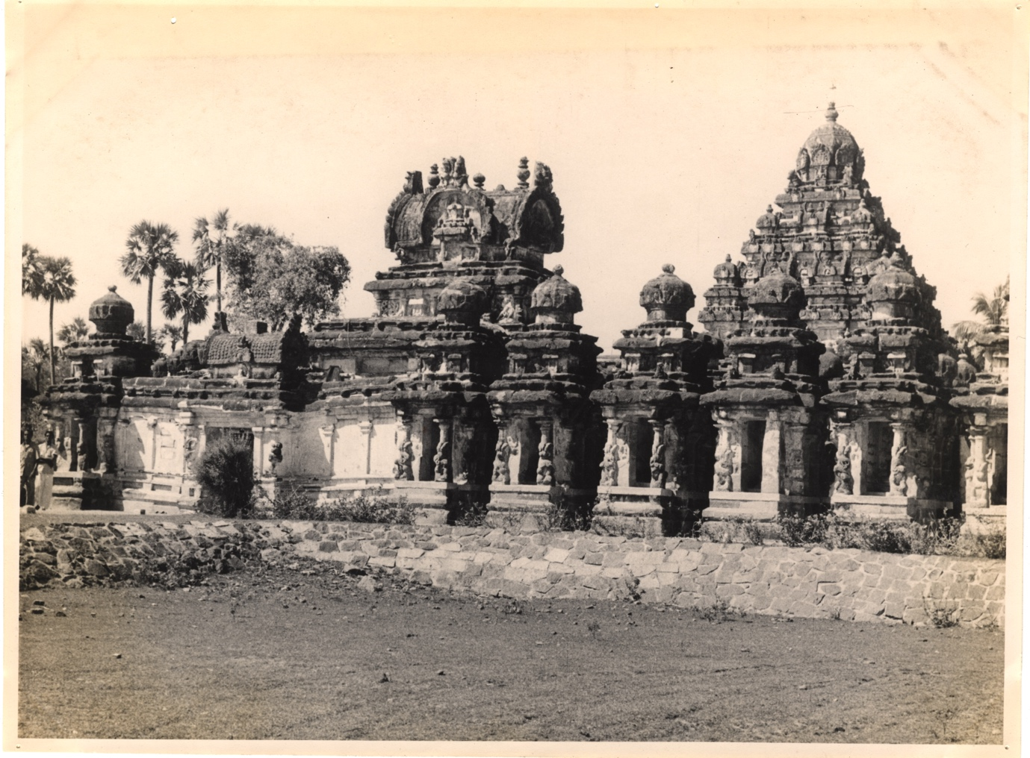

View of the Outer Shrines and Main Vimana

(Source: Archaeological Survey of India Archives)

1. **Architectural Evolution of the Temple Complex**

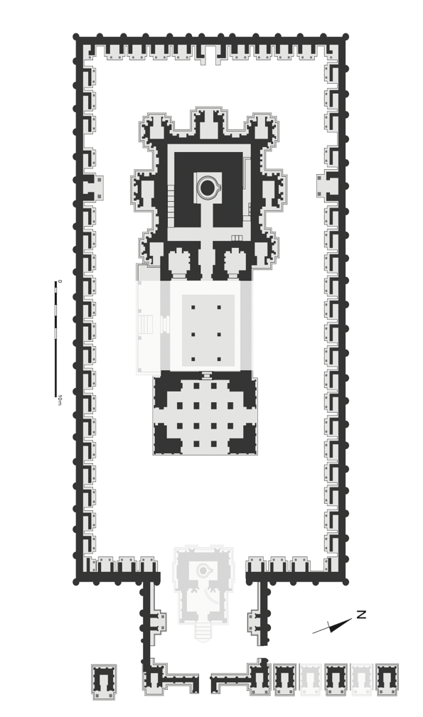

Main Shrine, Front Mandapa and Enclosure – Commissioned by Rajasimha

Source: Base Plan by Mark R. Williams, from Kaimal, 2020)

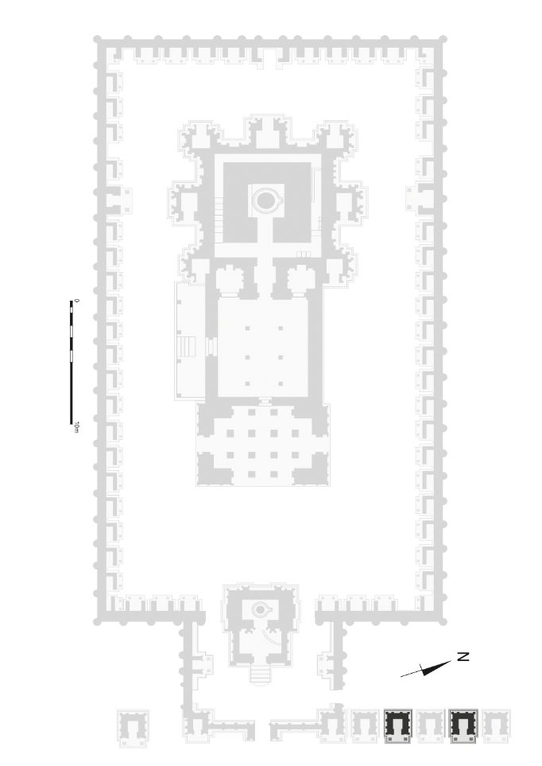

Outer Shrines – Commissioned by Rajasimha’s Queens: Rangapataka and Vilasavati

Source: Base Plan by Mark R. Williams, from Kaimal, 2020)

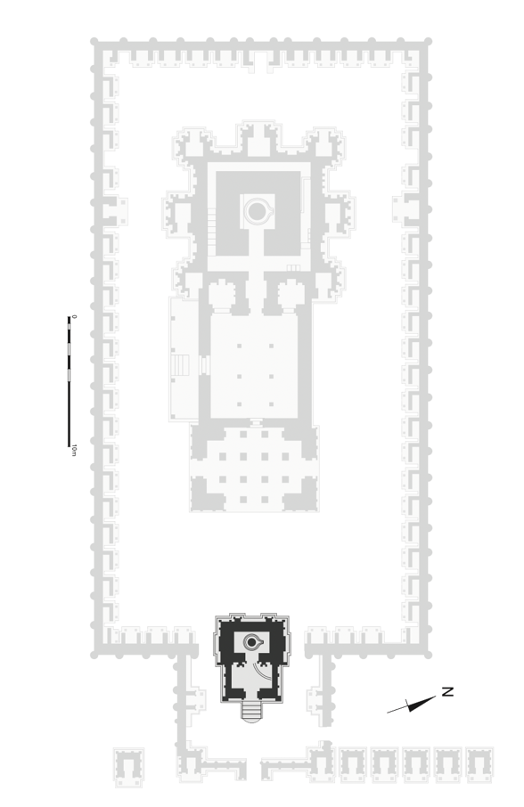

Front Shrine – Commissioned by Rajasimha’s Son Mahendravarman

Source: Base Plan by Mark R. Williams, from Kaimal, 2020)

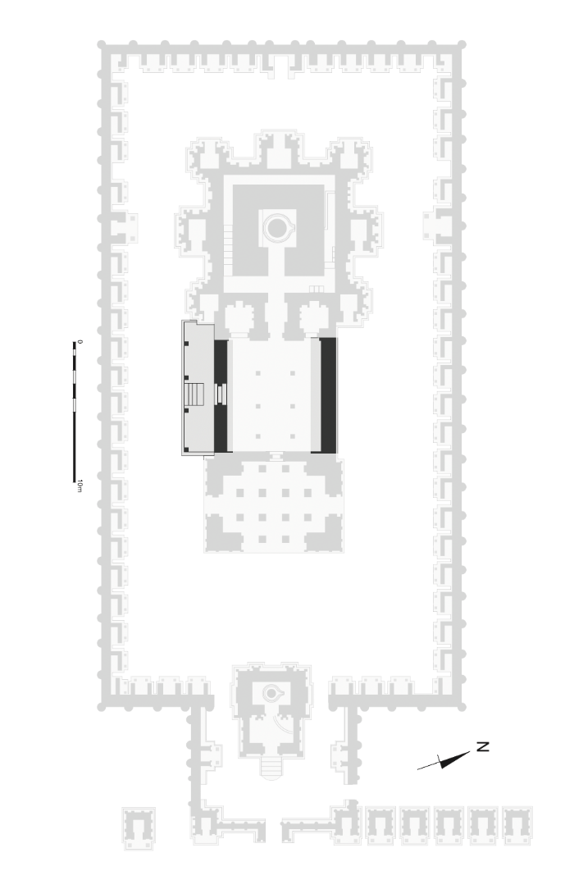

The windowless, single-storied hall that joins Rajasimha’s vimana to the open-sided mandapam: Later Addition – after the passing of Rajasimha

Source: Base Plan by Mark R. Williams, from Kaimal, 2020)

1. **Paintings & Murals**

The Kailasanathar Temple is not only renowned for its structural design but also for the painting fragments found within the temple. Though much of the original artwork has been lost to time, important remnants of murals and paintings have survived, offering a glimpse into the ancient artistic traditions of South India. Painting fragments were discovered on the walls of the temple's vestibule, specifically in the inner sanctum area and some of the smaller shrines surrounding the main deity. These fragments are believed to represent early Pallava art and are among the few surviving examples from that period. The paintings are made with **natural pigments** and **mineral colors**, and though heavily weathered, traces of vibrant reds, yellows, and whites are still visible. These murals primarily depict **Shaivite themes**, such as Lord Shiva in various forms

The stylistic approach of the Kailasanathar Temple paintings is considered a precursor to later **Chola murals** seen in temples such as the **Brihadeeswarar Temple**. According to art historians like **R. Nagaswamy**, these paintings show a dynamic yet delicate line work and an early use of shading techniques to create depth. **Nagaswamy, R.**: *Masterpieces of South Indian Art* - This book covers Pallava art and provides in-depth commentary on the painting fragments found in temples like Kailasanathar.

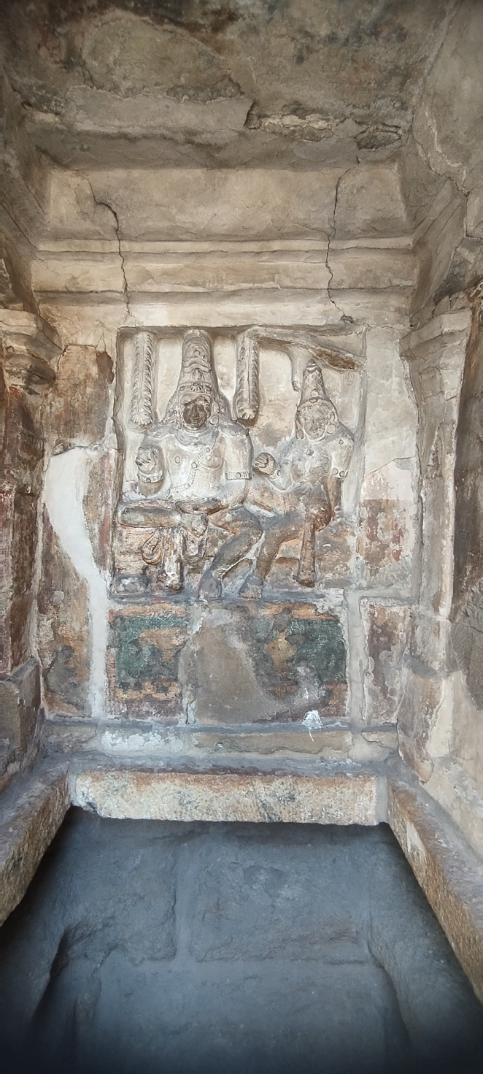

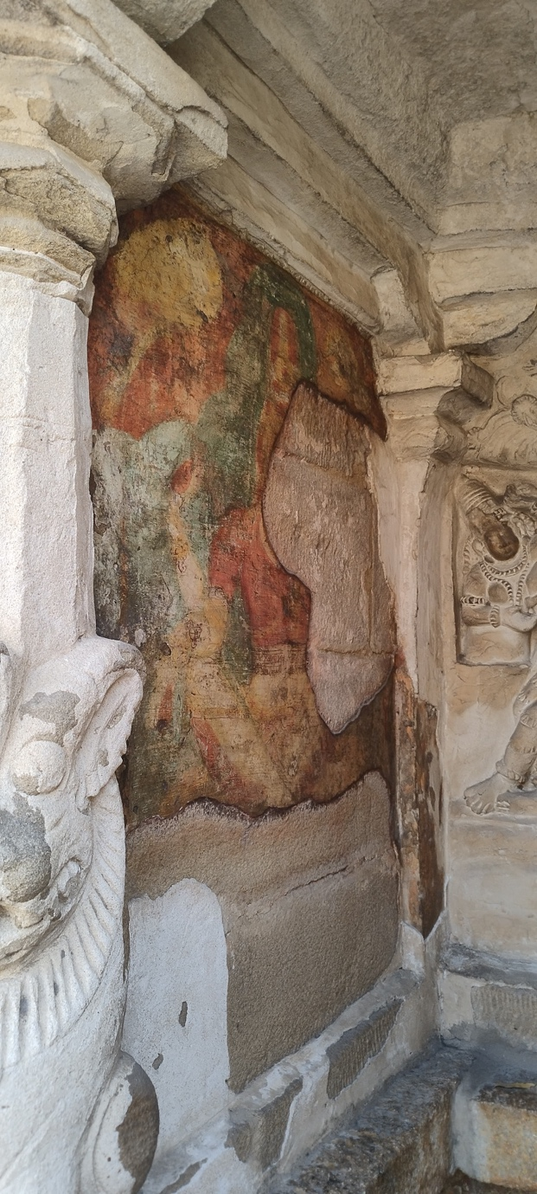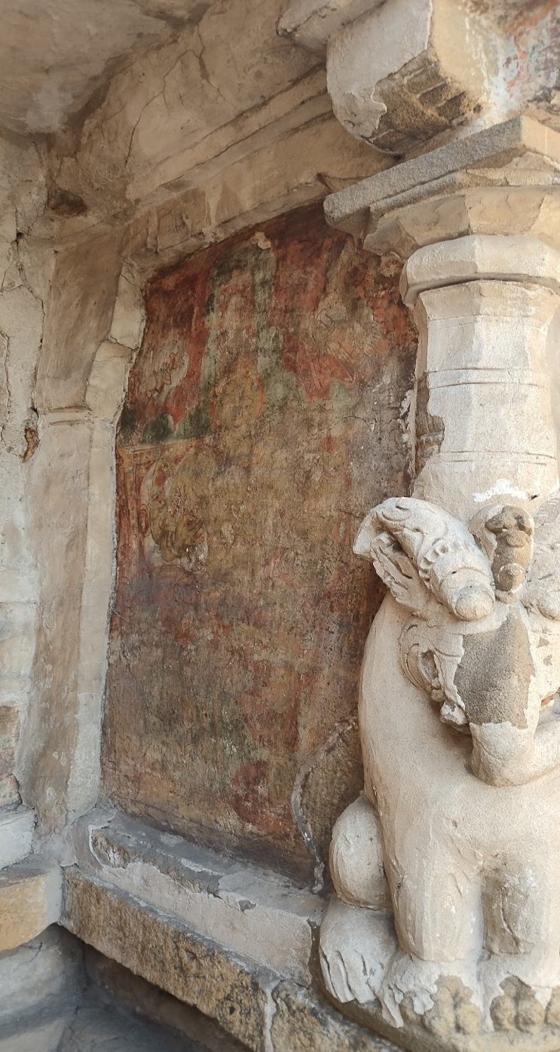

Painting Fragmants as seen in Kailasanathar Temple

Source: Williams, Conservation Architect, DRONAH

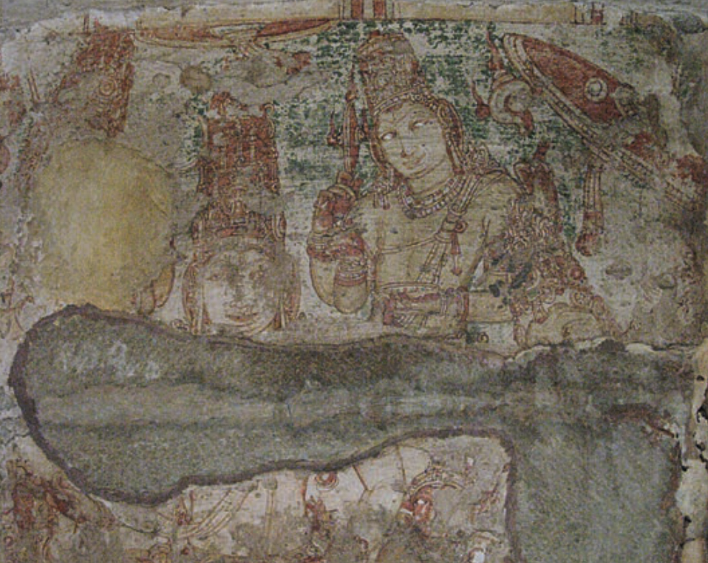

Traces of a painted representation of Shiva Somaskanda on the east-facing wall inside cell 43 in the northern side of Rajasimha’s *prakara*. From the top left: the red, matted locks of Brahma; Shiva’s taller matted locks, frontal face, and torso; golden Vishnu standing behind Shiva’s shoulder, his wheel (*chakra*) and conch on either side of his crowned head; the red-faced baby Skanda seated at Shiva’s elbow; the crowned head of Uma, in front of Vishnu’s elbow and beneath a tilted umbrella.

Source: Emmanuel Francis in Kaimal, 2020

1. **Shiva iconography and Popular Narratives**

The **Shiva iconography** in the Kailasanathar Temple, as detailed in the scholarly work *La Création d'une Iconographie Śivaïte Narrative* by Brigitte Khan Majlis, offers a rich narrative of Shiva's various incarnations and mythological episodes as depicted in the Pallava temples. This work delves deeply into the narrative iconography of Lord Shiva and how it was developed during the Pallava period, especially in temples like Kailasanathar.

### Key Aspects of Shiva Iconography

1. **Narrative Representation of Shiva's Incarnations**:
   * According to Majlis, the Kailasanathar Temple is central to the development of **narrative iconography** in South India, where multiple **incarnations of Shiva** are depicted in various postures and scenes. The representations include both **cosmic forms** and **humanized depictions** of Shiva, emphasizing his role as a multifaceted deity.
   * The **Lingodhbhava** form is one of the most iconic representations. In this depiction, Shiva emerges from the eternal flame of a Shiva Linga, demonstrating his superiority over Vishnu and Brahma. This symbolic portrayal highlights the **limitlessness** of Shiva and is a frequent subject in Pallava temple art​
2. **The Dance of Shiva (Nataraja)**:
   * One of the key narrative sequences explored in the Kailasanathar Temple is Shiva as **Nataraja**, performing the cosmic dance that signifies the cycle of creation, preservation, and destruction. Majlis explains how this form is central to the **Shaivite mythology** and its iconography in Pallava art. The Nataraja at Kailasanathar embodies the energetic aspect of Shiva, shown through dynamic postures and intricate symbolism such as the flames encircling him .
   * The depiction of **Nataraja** in the Kailasanathar Temple is considered a precursor to later, more elaborate representations in the Chola period. The Nataraja motif evolved significantly under Pallava patronage, both artistically and religiously.
3. **Shiva as Bhikshatana**:
   * Another important form of Shiva depicted in the temple, as highlighted by Majlis, is **Bhikshatana**, or the **divine mendicant**. This incarnation of Shiva portrays him in an ascetic form, wandering with a begging bowl. This representation contrasts with his more fierce, destructive forms and highlights his ascetic and benevolent aspects.
   * This form is closely associated with Shiva’s renunciation and self-control, important themes in Shaivism, and is depicted with rich narrative detailing in the temple’s bas-reliefs​.
4. **Shiva with Parvati (Somaskanda)**:
   * The temple also prominently features depictions of Shiva with his consort **Parvati**, in the form known as **Somaskanda**. This portrayal is significant as it humanizes Shiva, depicting him as a family man with Parvati and their child Skanda (Kartikeya).
   * This form is critical to the temple’s narrative iconography, representing the balance of divine power with familial love and affection, conveying the complementary nature of Shiva and Parvati as both cosmic forces and parental figures​.
5. **Shiva Slaying Demons (Tripurantaka)**:
   * Majlis notes the **Tripurantaka** iconography, where Shiva is depicted as a destroyer of the three demonic cities, symbolizing the destruction of evil and ignorance. This form is celebrated in the temple’s reliefs, showing Shiva wielding his bow to annihilate the demon cities in his warrior form .
   * This imagery aligns with Shiva’s role as both a protector and destroyer in Shaivite theology.

### **Symbolism in Iconography**

1. **Attributes of Shiva**:
   * Majlis emphasizes the rich symbolism in the iconographic elements, such as the **third eye** symbolizing Shiva’s power of destruction, the **trident (Trishula)** representing his control over the cosmic cycle, and the **damaru (drum)** symbolizing the rhythm of creation .
   * The **serpent** coiled around Shiva’s neck represents his mastery over death and time, while the **crescent moon** on his forehead represents immortality and control over time.
2. **Integration with Architecture**:
   * As explained by Majlis, the integration of Shiva’s iconography with the architectural layout of the temple is deliberate and spiritual. Each depiction of Shiva is placed in a way that complements the temple’s overall religious purpose, guiding the devotee through various forms and incarnations of the god as they move toward the sanctum. This progression mirrors the spiritual journey of understanding the different aspects of the divine .

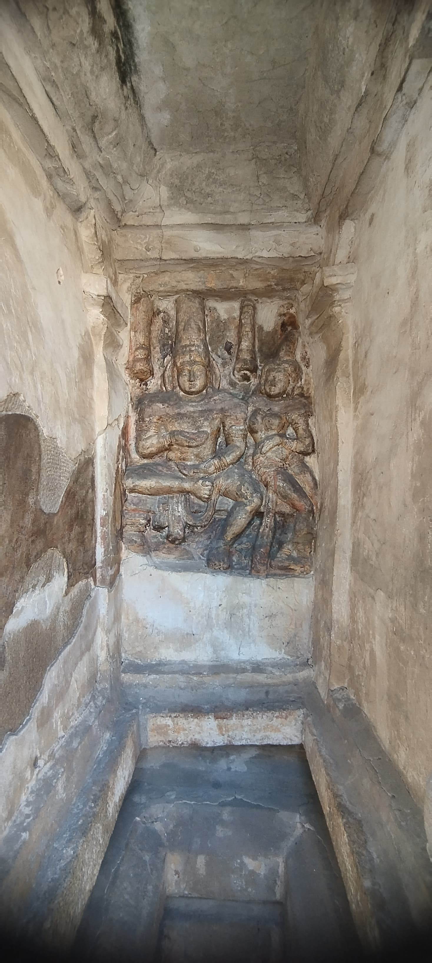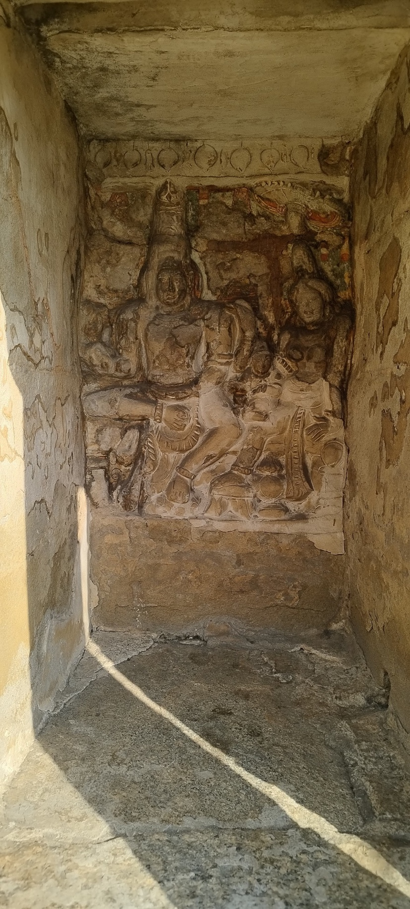

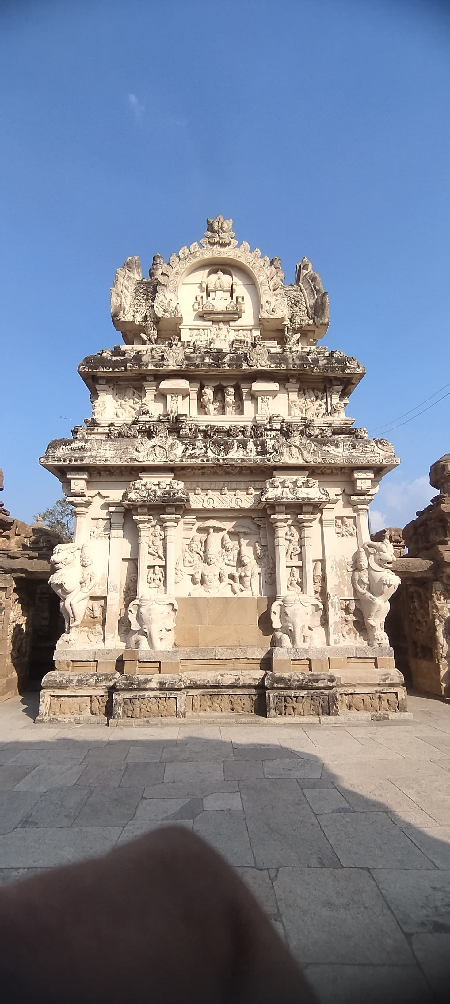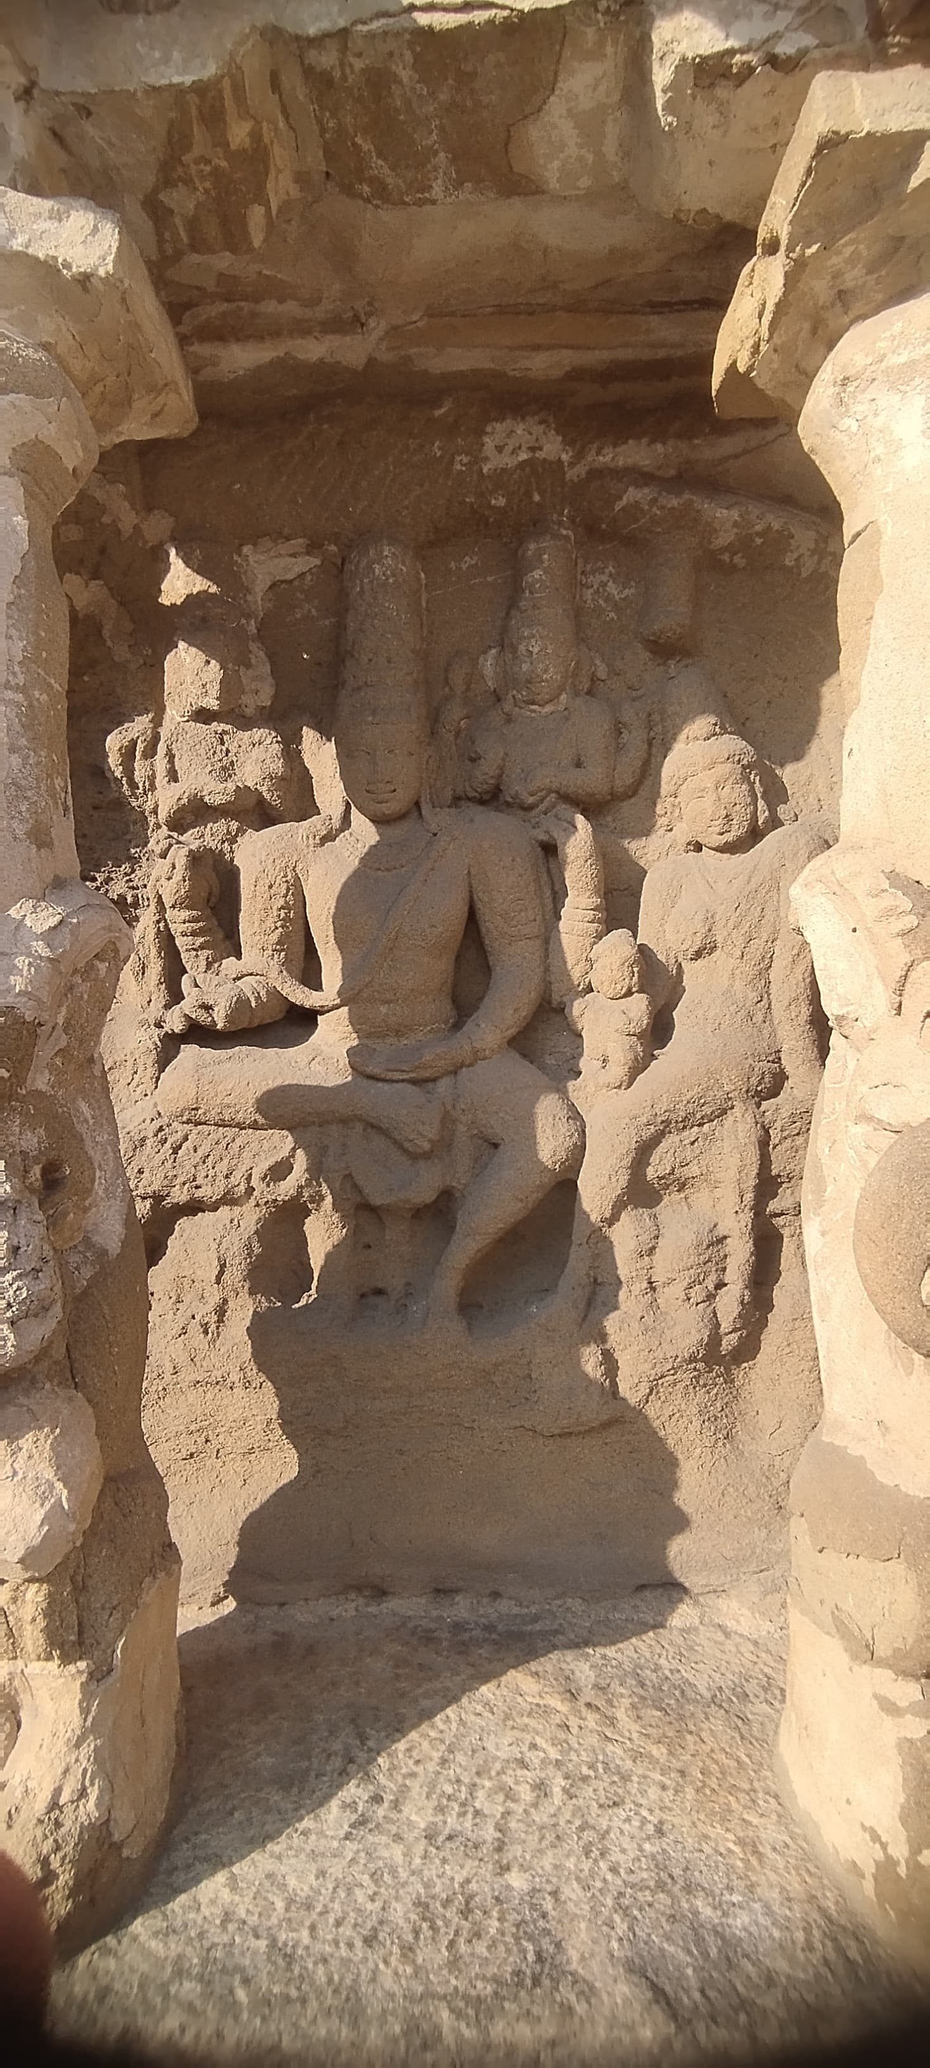

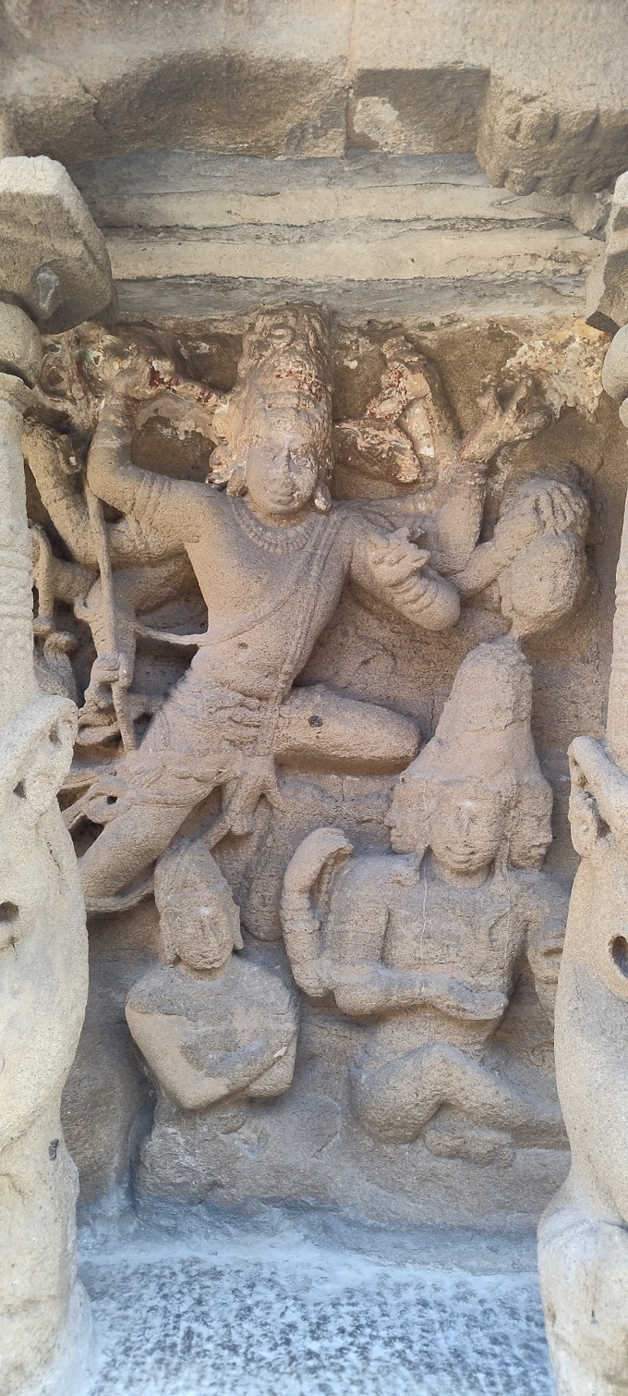

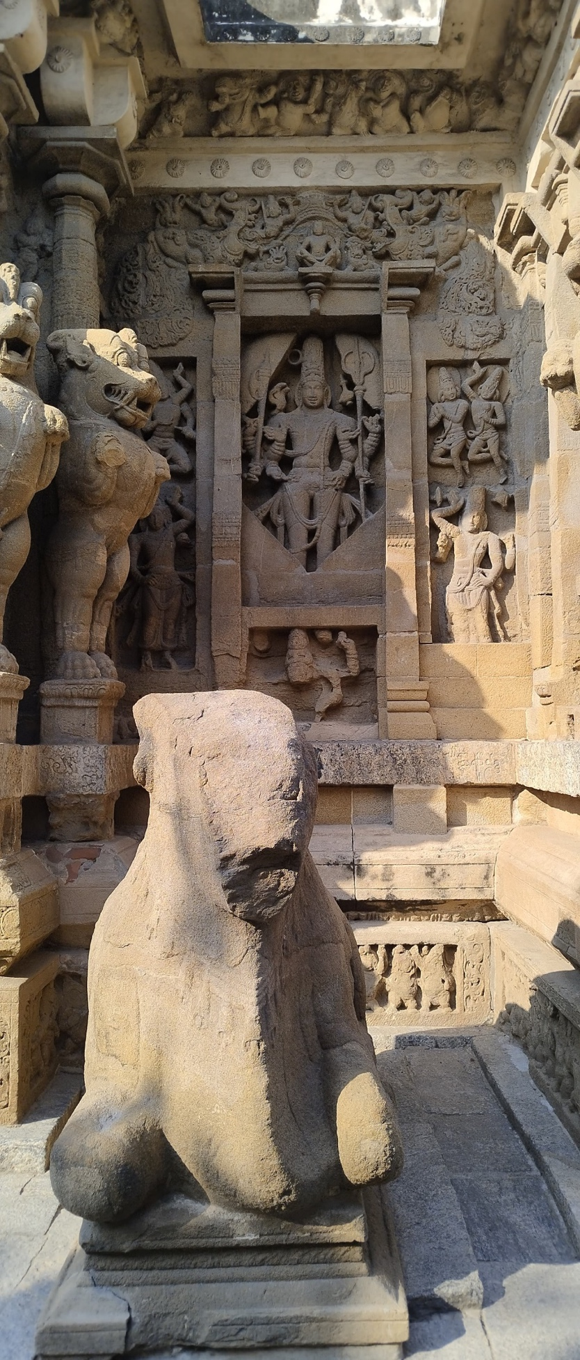

Forms of Shiva (As seen through the iconography in the temple Complex)

Source: Williams, Conservation Architect, DRONAH

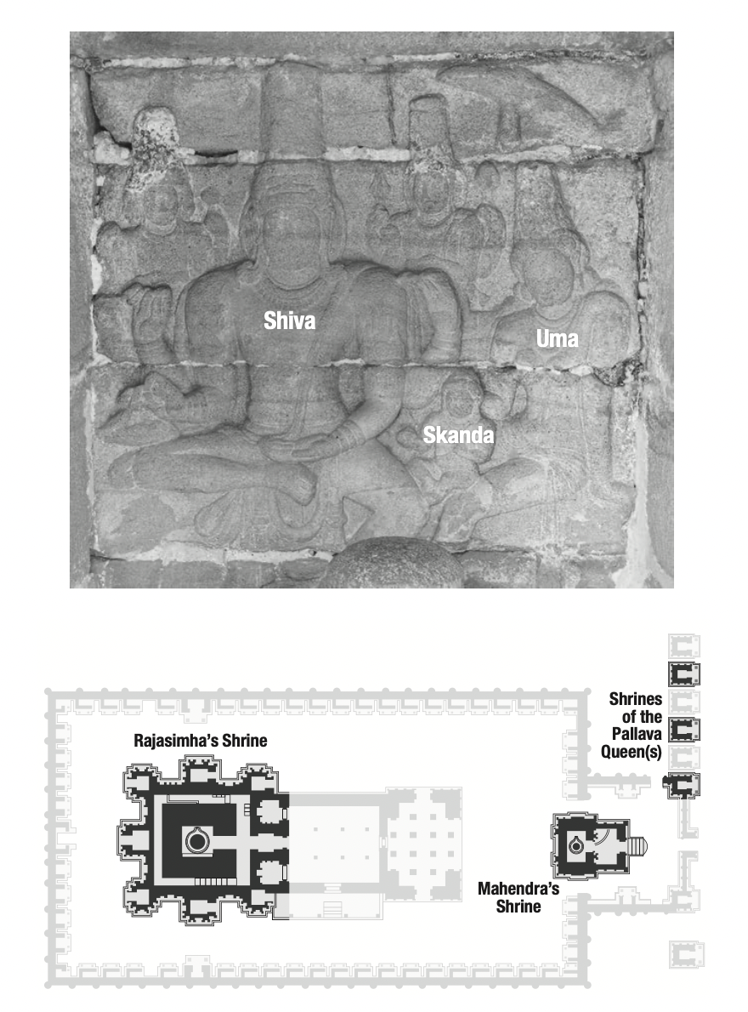

The layout of Rajasimha’s *vimana*, Mahendra’s *vimana*, and shrines built by Pallava queens (below) and a Shiva Somaskanda sculptural relief (above). Note that in the relief and the ground plan, the regal father is to the left, the queenly mother to the right, and the son interposed between them.

Source: Mark R. Williams in Kaimal, 2020

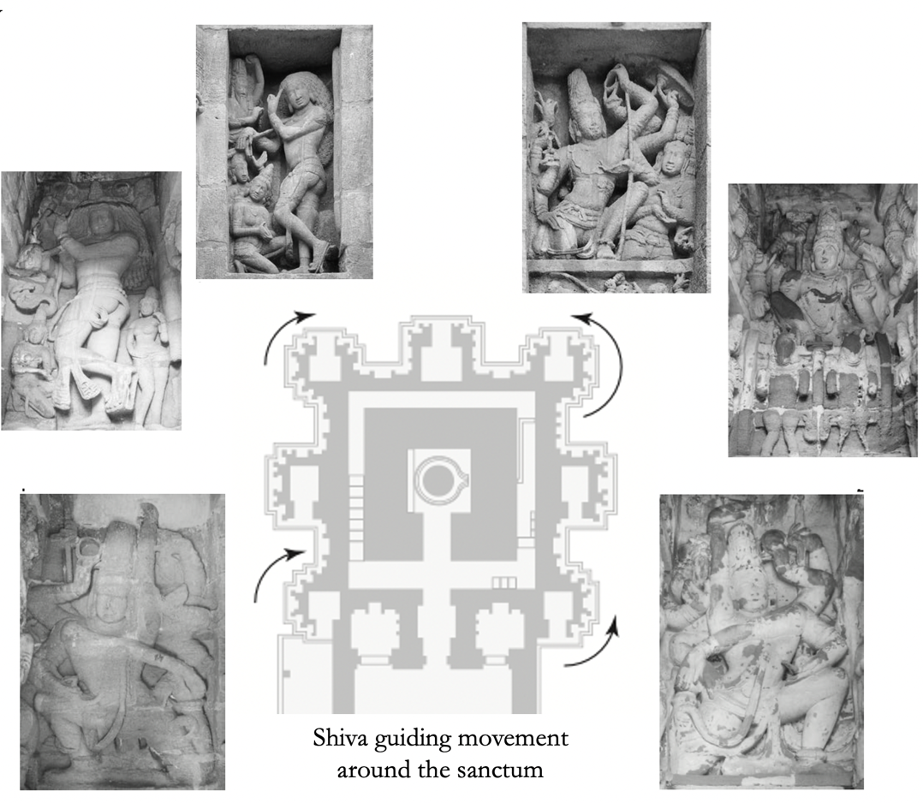

Symbolism in Planning and Iconography at the Kailasanathar Temple

(Derived from Kaimal, 2020)

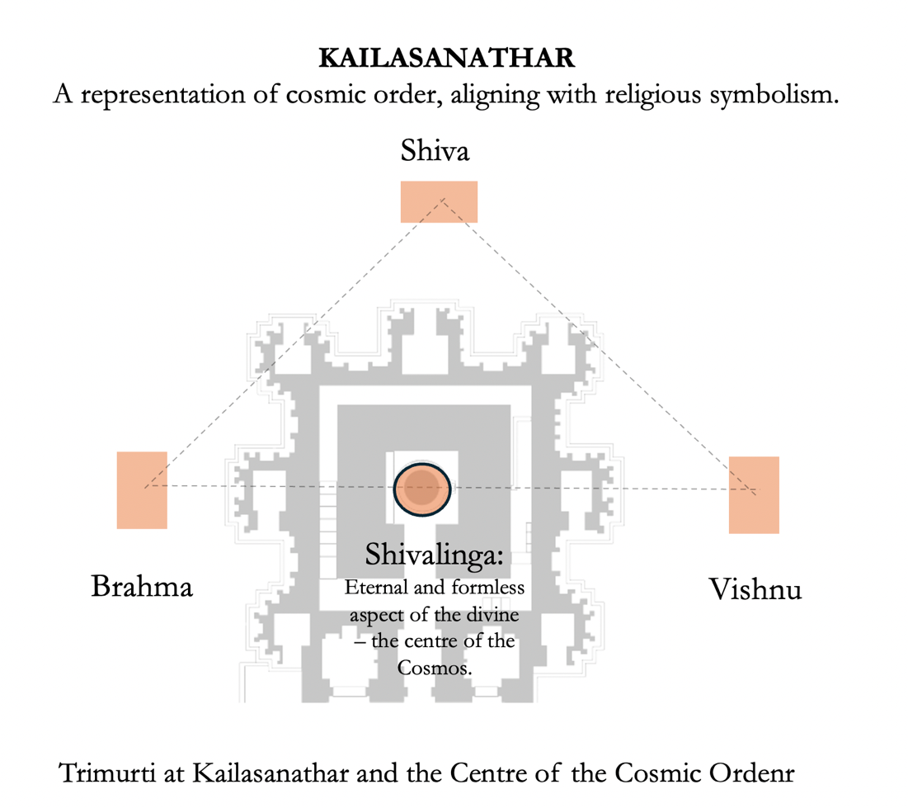

1. **List of Sculptures at Kailasanathar**

**List of Sculptures (By R Nagaswamy)**

1. **Sculptures in the front enclosure around the Mahendra shrine:**

**South of the entrance:**

1. Dvarapala

2. Siva.

3. Siva.

4. Agastya.

5. Durga.

6. Brahma with Sarasvati.

7. Dvadasa Adityas.

8. Katyayani

**North of the entrance:**

1. Dvarapala.
2. Siva.
3. Siva.
4. 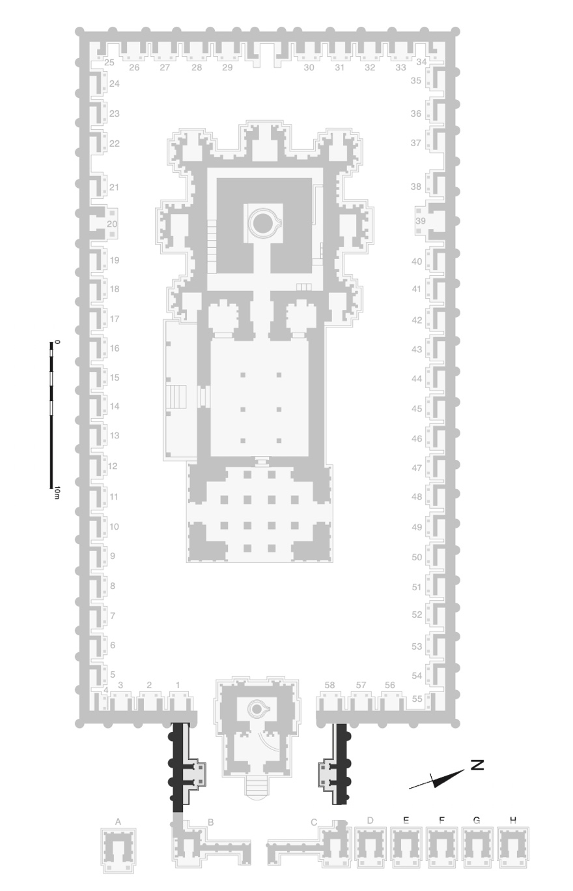Lakshmi.
5. Ganésa.
6. Vishnu with Sri.
7. Ekadasa Rudra
8. Lakshmi

A loose sculpture in front of Ganésa represents Ardhanari.

**II. Sculptures in the main enclosure:**

As the visitor goes around the prakara in pradakshina (clockwise) he may notice the row of cells bearing serial numbers on the base.

1. Somaskanda.
2. Somaskanda.
3. Somaskanda. Padadévata representing Agni with consort.
4. Ganésa.
5. Durga.
6. Subrahmanya.
7. Dévi seated.
8. Tripurantaka.
9. Vishnu on Garuda.
10. Narasimha fighting with Garuda.
11. Vishnu.
12. Trivikrama.

Padadévata representing Yama with consort.

1. Vishnu supporting mantara during Amrta madana.
2. Siva Tandava.
3. Siva as Brahma sirascheda murti.
4. Fight between Kriata and Arjuna.
5. Yogesamurti.
6. Jalandhara Vadha.
7. Destruction of Daksha yaga.
8. Jyéshta on the wall of the enclosure. 20. Brahma seated with consort.
9. Durga on the wall of the enclosure. 21. Tripurasamhara.
10. Sapta mata on the wall of the enclosure. 22. Kalasamhara.
11. Bhairavi on the wall of enclosure. 23. Gajasamhara.
12. Agastya on the wall of the enclosure. 24. Gangadhara.
13. Urdhva tandava.
14. Somaskanda.
15. Somaskanda.
16. Somaskanda.
17. Somaskanda.
18. Somaskanda.
19. Somaskanda.
20. Somaskanda.
21. Somaskanda.
22. Candesanugrhamurti
23. Siva and Parvati.
24. Yoga Dakshinamurti.

Ekadasa Rudra on the wall of the enclosure.

Saraswati on the side wall.

37. Samhara Tandava.

39. Vishnu with Sri and Bhu.

Trivikrama on the Side wall.

40. Brahma-Anugrha Siva.

41. Indra-Anugraha Siva.

42. Ravana Anugraha Siva.

43. Vishnu-Anugraha Siva.

44. Kalyana sundara.

45. Umamahésvara.

46. Tandava probably representing Vishapaharana.

47. Kama-Anugraha Siva.

48. Vinadhara.

49. Linghédhbhava.

50. Gangadhara.

51. Somaskanda.

52. Bhairava.

53. Bhikshatana.

54. Ravana and Val Worshipping Atmalinga.

 Padadévata representing Isdna.

55. Candikésvara.  
56. Somaskanda

57. Somaskanda

58. Somaskanda

**Ill. Sculptures in the front mandapa**

South Side:

1. 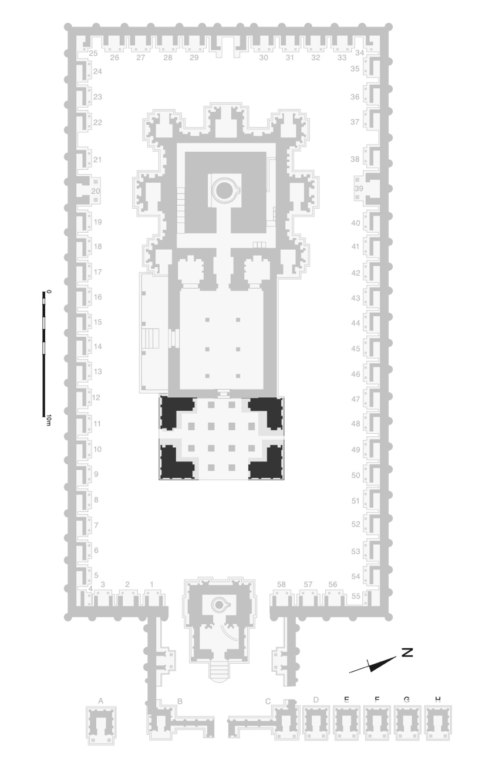Lakshmi
2. Saraswati

North Side:

1. Durga
2. Jyestha

**IV. Sculptures on the main walls of the sanctum, as one goes around in pradakshina.**

1. Gaurprasada.
2. Sarasvati,
3. Umamahésvara.
4. Lakshmi.
5. Yoga Dakshinamurti.
6. Harthara.
7. Lingddhbhava.
8. Bhikshatanar.
9. Sandhya Tandava.
10. Samhara Tandava.
11. Ganésa.
12. Vinadhara.
13. Urdhva Tandava.
14. Kalasamhiara.
15. Simhavahini.
16. Tripurasamhara.
17. Bhairavi.
18. Bhairava.
19. Yogesamiurti
20. Kausiki.
21. 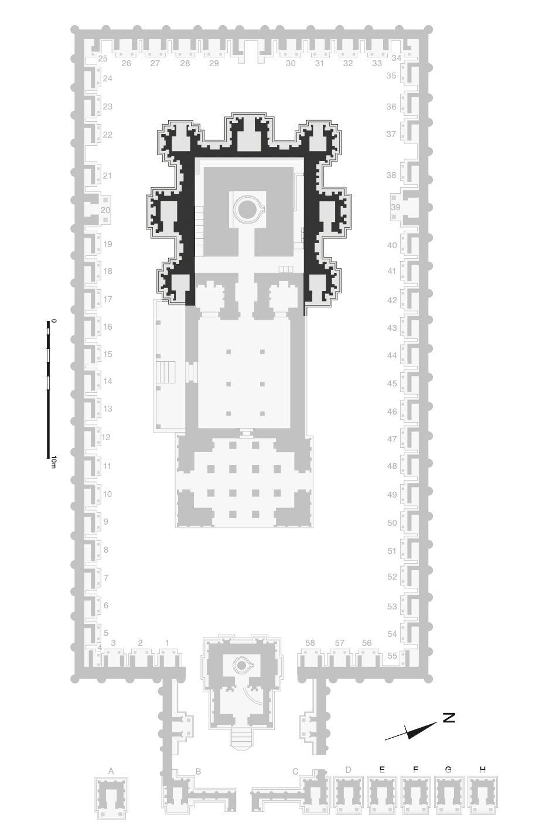Durga.
22. Jyéshta.
23. Gangadhara

|  |  |  |
| --- | --- | --- |
| **Descriptions of specific sculptures (By Padma Kaimal):** | | |
| **S.NO.** | **SCULPTURE** | **DESCRIPTION AND LOCATION** |
| 1 |  | Shiva dancing with deeply flexed legs (Natesha). This relief occupies the shrine embedded at the south end of the east wall of Rajasimha’s *vimana*. |
| 2 |  | Shiva touches Uma’s chin tenderly. A heavy coat of lime plaster from perhaps the nineteenth century still coats this relief. East end of the south wall, Rajasimha’s *vimana.* |
| 3 |  | Shiva and Uma sit enthroned (Shiva Umasahita). Lakshmi/Shri is on the left in the posture adopted by kings during their consecration (*abhisheka*). Two elephants pour water over her head. The goddess on the right may be Saraswati. East recess in the south wall, Rajasimha’s *vimana*. |
| 4 |  | Shiva Dakshinamurti sits under a tree. Deer, lions, sages, and a royal male figure surround him. Central projection on the south wall, Rajasimha’s *vimana*. |
| 5 |  | Shiva Bhikshatana with two wives of the sages in the Pine Forest. At the upper left, a sage waves his fist in anger. Above, a small panel presents Shiva dancing with his legs deeply bent (Natesha). West end of the south wall, Rajasimha’s *vimana*. |
| 6 |  | Shiva Bhikshatana carved inside the shrine embedded at the south end of the west wall of Rajasimha’s *vimana*.   |
| 7 |  | Shiva dancing with both legs extended, and the toes of his right foot pointing to the sky (Urdhvatandava). North recess in the west wall, Rajasimha’s *vimana*. |
| 8 |  | A black and white image of a square structure  Description automatically generatedShiva kicking or leaping on a crumpled enemy, perhaps Kala/ Time (Kalarimurti). Above, a goddess armed with a spear and trident pursues a fleeing warrior who has dropped his mace. West end of the north wall, Rajasimha’s *vimana*. |
| 9 |  | Shiva sits deep in yogic meditation above the king Jalandhara, who is dying from the disc (*chakra*) Shiva has thrown into his shoulder. Central projection on the north wall, Rajasimha’s *vimana*. |
| 10 |  | The Goddess stands at her ease, one foot on the shoulder of her lioness. To the right, an enthroned goddess poses regally with one leg resting on her bench as a deer and a lion peer over her shoulders. To the left, Jyeshtha sits in the posture adopted by Lakshmi and by kings being consecrated (*abhisheka*). Her adult children look over her shoulders. East recess in the north wall, Rajasimha’s *vimana*. |
| 11 |  | Relief carving of Shiva Somaskanda, Shiva seated with Uma and their baby Skanda between them. Rearing leonine creatures (*yali*) frame the back of their wide throne. Brahma and Vishnu stand behind Shiva, saluting him. A female attendant stands behind Uma. An umbrella shelters Skanda and Uma. This relief is high on the north end of the west of Rajasimha’s *vimana*, above the doorway into the attached shrine housing a relief of Shiva Bhikshatana. |
| 12 |  | Ganesha, an embodiment of auspiciousness, facing south from the outer surface of the shrine embedded at the center of the west wall, Rajasimha’s *vimana*. |
| 13 |  | A fierce goddess dancing with weapons. This figure faces north from the outer surface of the shrine embedded at the south end of the west wall, Rajasimha’s *vimana*. |
| 14 |  | The shrine embedded at the north end of the west wall of Rajasimha’s *vimana*. This is the only side of the building where the basement molding carries regal lions and elephants instead of rows of dancing dwarves. At this corner of the building, the inscription in the granite course declares the arrival of the patron in the Pallava lineage. Inside the shrine, Shiva Tripurantaka drives his chariot. Above the doorway sits Shiva Somaskanda attended by Vishnu and Brahma. |
| 15 |  | Sculptures on the west wall of Rajasimha’s *prakara*. Relief carvings of Shiva with wife and son (Shiva Somaskanda; marked by diamonds) alternate regularly with relief carvings of a royal couple who have no baby (marked by stars). The divine couples with babies sit inside the temple-shaped cells. The royal couples without babies sit in between those cells. |
| 16 |  | The large relief on the rear, west-facing surface of Mahendravarman III’s *vimana*. A king and queen sit enthroned without a child, attended by three women bearing fly whisks (*cauri*). This photo from 2010 shows the plaster coating applied in 2000. |
| 17 |  | Shiva Harihara enthroned, his right side showing Shiva’s signs, his left side showing Vishnu’s signs. This relief is on the east surface of the shrine embedded at the center  of the south wall of Rajasimha’s *vimana*. |
| 18 |  | The goddess Durga on her lion. This relief is carved in the southern passageway between the small courtyard and the large courtyard, seen from the large courtyard (the west). |
| 19 |  | Shiva catching the river goddess Ganga in his hair (Shiva Gangadhara). Other deities attending this miracle line the three walls inside this especially large shrine embedded at the center of the west wall, Rajasimha’s *vimana*. |
| 20 |  | Shiva Lingodbhava manifests in an endless pillar of flame. Below is visible the crown and hand of Vishnu as he takes the form of a boar to dig down to find the pillar’s root. At the upper left, Brahma flies up to find the pillar’s top. At the lower left and right, Brahma and Vishnu in human form salute Shiva. At the upper right, the moon and sun salute Shiva. West recess in the south wall, Rajasimha’s *vimana*. |

1. **Documentation of Sculptures by ASI (ASI Archives)**

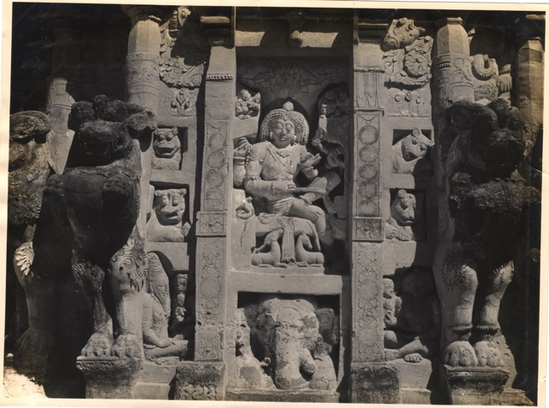

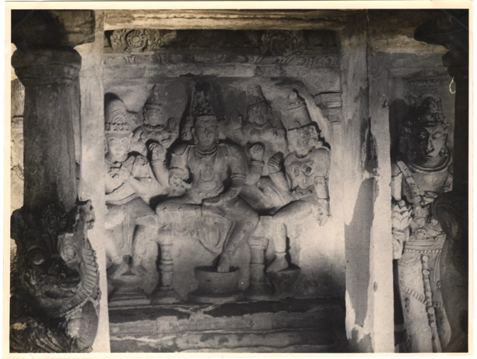

Imagery on Rajasimha’s Vimana telling the story of Skanda.

Dakshinamurti, South Wall, Rajasimha’s Vimana.

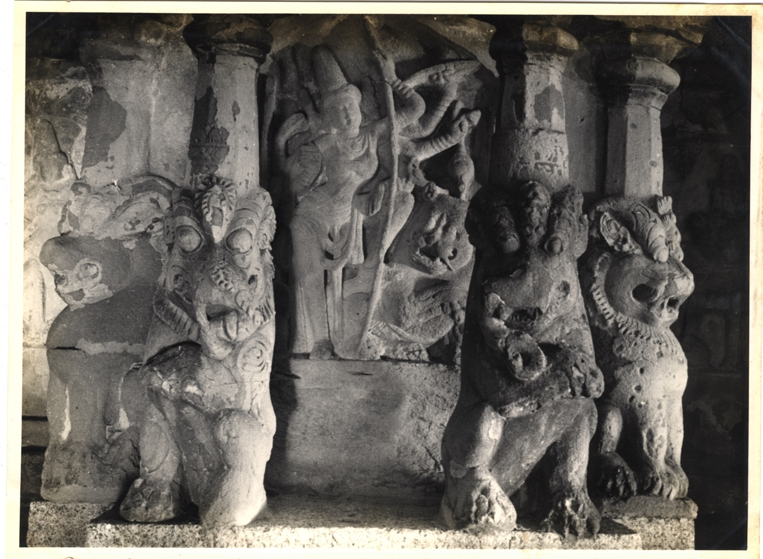

The relief showcasing the Goddess as triumph. Leonine creatures (*yali*) rear outward in all directions.

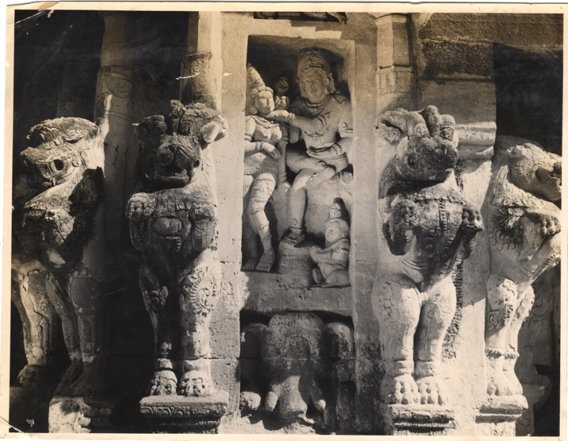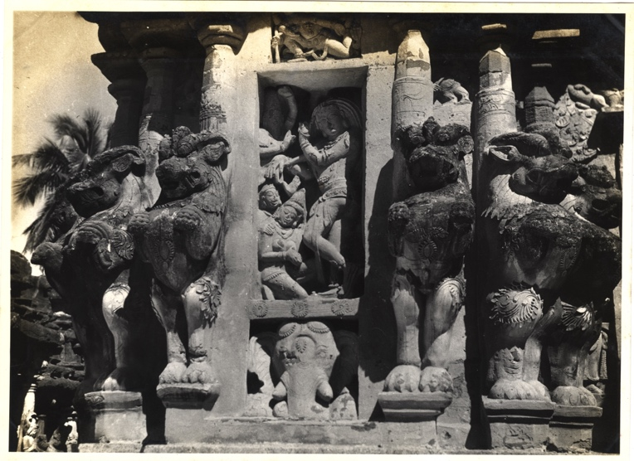

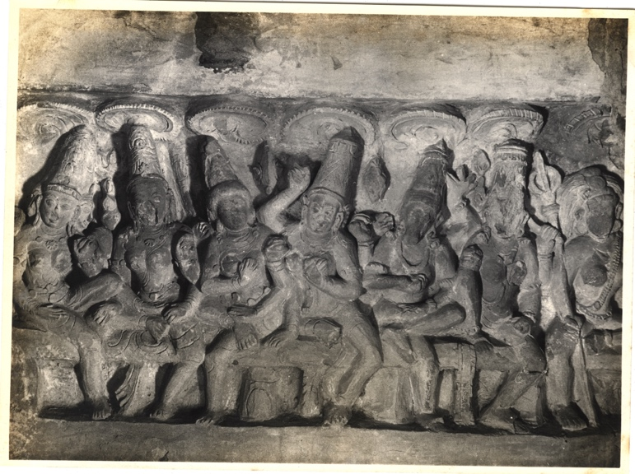

The Seven Mother Goddesses (Sapta Matrika) – South Wall of Rajasimha’s Prakhara

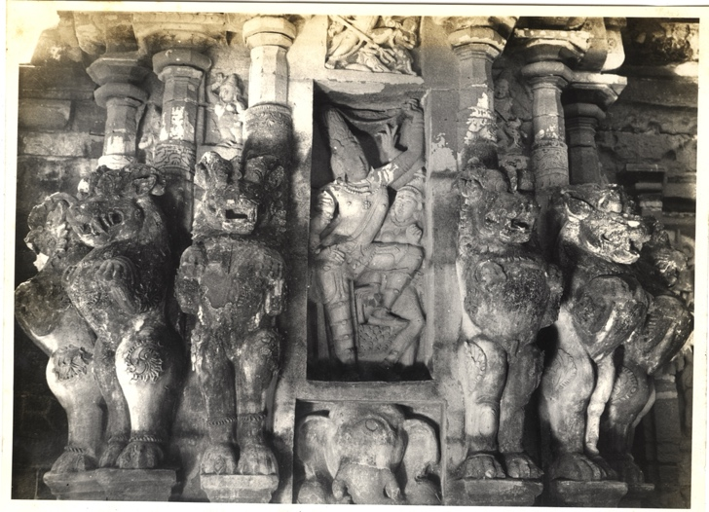

The relief of Shiva catching Ganga. Leonine creatures (*yali*) rear outward in all directions from octagonal pilasters.

Figure of Shiva on Rajasimha’s Vimana

Shiva touches Uma’s chin tenderly. East end of the South Wall, Rajasimha’s Vimana.

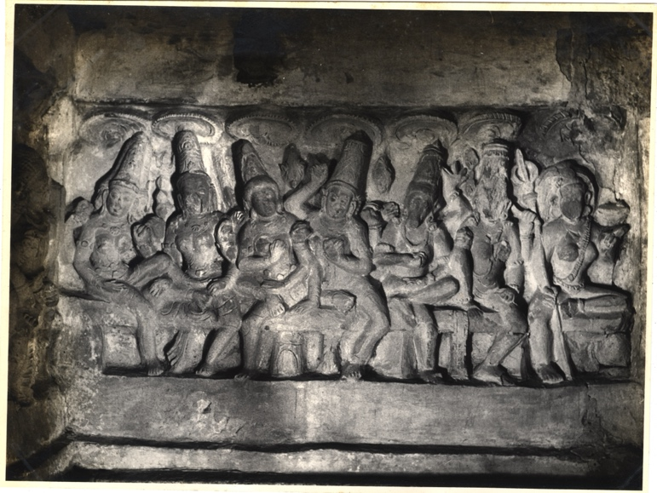

The Seven Mother Goddesses (Sapta Matrika) – South Wall of Rajasimha’s Prakhara

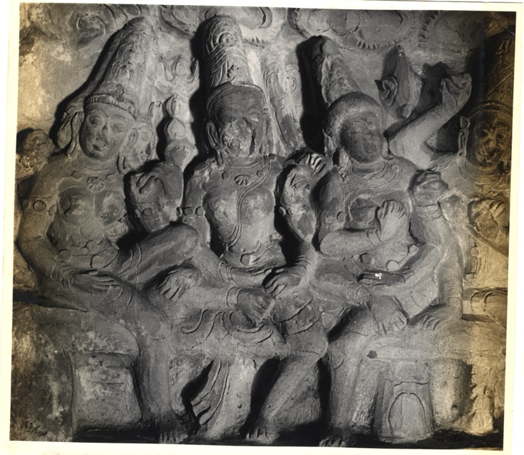

Part of The Seven Mother Goddesses (Sapta Matrika) – South Wall of Rajasimha’s Prakhara

1. **Inscriptions:**
2. An inscription in excellent Pallava grantha characters, on the basement, records the construction of the temple by the Pallava ruler, Rajasimha, whose lineage and other accomplishments are detailed in excellent Sanskrit poetry.

‘While this prince enjoyed the whole world, which he had conquered by valour combined with polity, and in which he had killed rebels and humbled kings, he erected this extensive and wonderful house of Hara (Siva), which resembles his fame and the laughter of Hara.’

‘“May Samkara (Siva) whose terrible ornaments are the coils of the king of serpents, and who is praised by the hosts of the kings of gods and of demons, reside for a long time in this temple (called) the holy Rajasimha-Pallavesvara

“May the bull-marked (Siva) always lend his presence to this temple of stone, called Rajasimhesvara, which

touches the clouds with its top, which robs Kailasa of its beauty, and which was built by that pious king of kings, who made all quarters obedient to his orders and (who proved) a royal hon (Rajasimha) to the dense

troops of the elephants of his daring foes!”

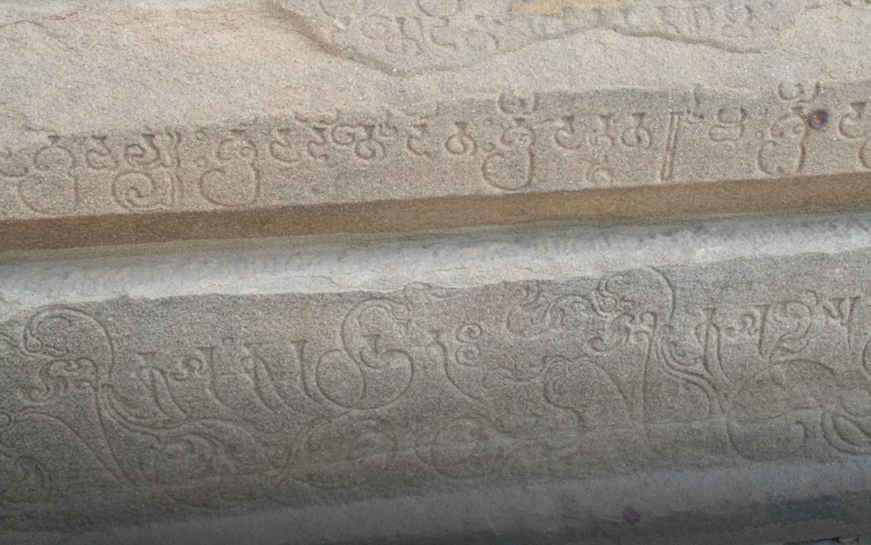

Foundation Inscription (Source: Akshatha A, Friends of Heritage Sites, Tamil Nadu)

1. In addition to the dedicatory inscription on the base of the main shrine, Rajasimha has left over 300 of his titles engraved on the row of cells in the enclosure. These titles are carved in different scripts on the base of the cell shrines. Each title is repeated in four different scripts, the Nagari, simple grantha, ornate grantha and florid grantha in which letters are entwined to form designs of birds, snakes, creepers etc. Particularly the last-mentioned variety engraved on the wider part of the base is a fine piece of calligraphy. These scripts show, not only the standard attained in the art of writing but also Rajasimha's love of variety.

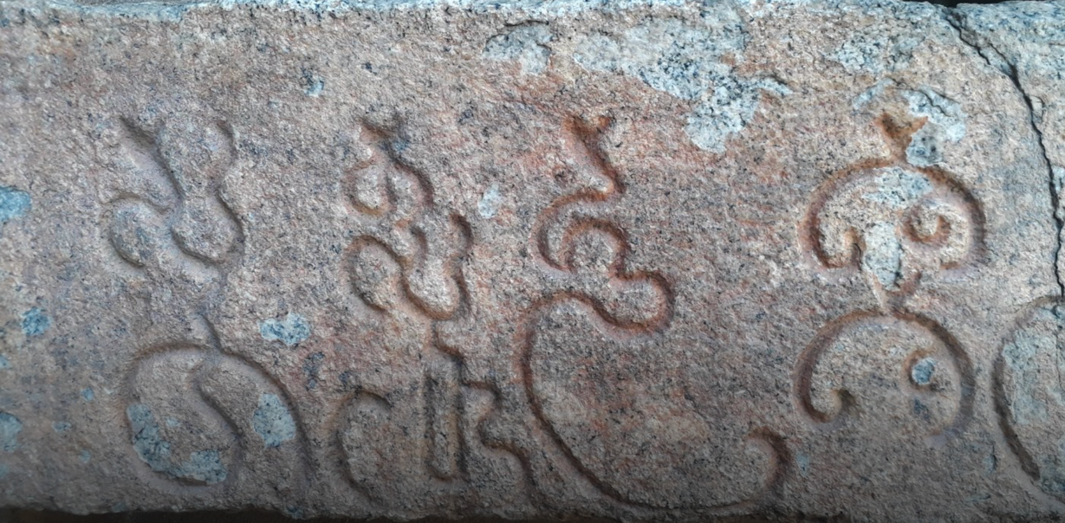

Title Inscription (Source: Akshatha A, Friends of Heritage Sites, Tamil Nadu)

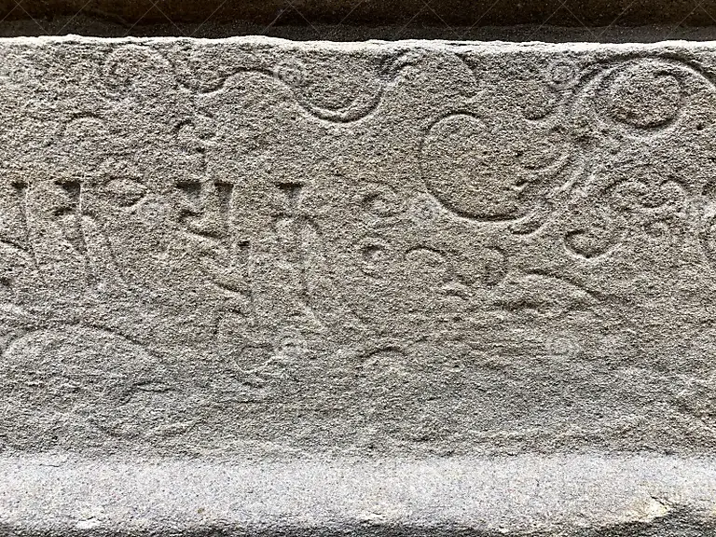

Title Inscription (<https://www.dreamstime.com/tamil-inscriptions-ancient-text-carved-walls-historical-kanchi-kailasanathar-temple-kanchipuram-tamilnadu-india-image206383595>): purchasable image

1. Mention has been made earlier of the Kannada inscription of Vikramaditya in the front mandapa of the temple. A rare inscription in Kannada, that belongs to the king Vikramaditya II- Chalukya dynasty, can be found engraved in one of the pillars in the *Mukha Mandapa*. The inscription dates back to the 8th Cent CE.  The Pallavas and the Chalukyas were rivals,  who fought each other all through the pages of history. When Vikramaditya II marched to Kanchipuram, to avenge the defeat by the Chalukyas, he was taken aback by the beauty of the Kailasanatha Temple and retreated. Vikramaditya II took architects from Kanchipuram and built a similar temple in Pattadakkal. The temple prevented another war between the two great Kingdoms.

**[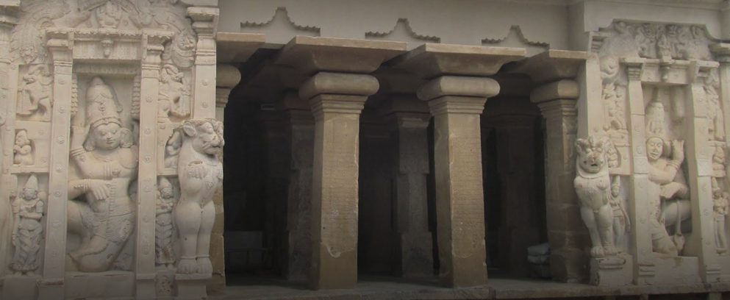](https://artsandculture.google.com/asset/kailasanatha-temple-a-view-of-sculpture-1/EgEiGagSIkh5iA" \o "Kailasanatha Temple: A view of Sculpture-1)**

Figure: Chalukyan Inscription (Source: Akshatha A, Friends of Heritage Sites, Tamil Nadu)

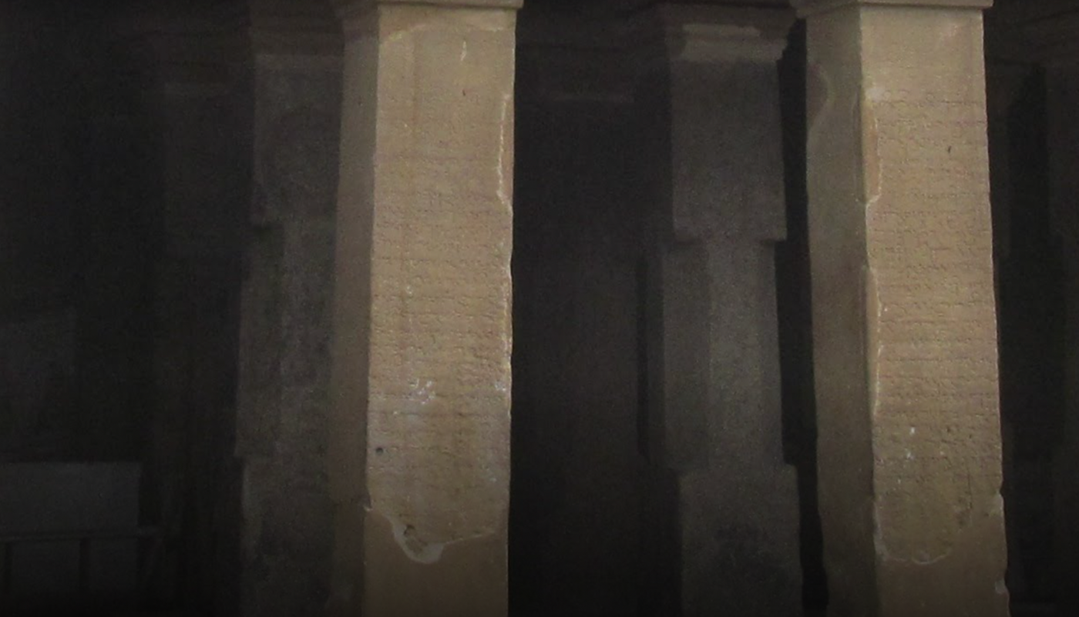

Figure: Chalukyan Inscription (Source: Akshatha A, Friends of Heritage Sites, Tamil Nadu)

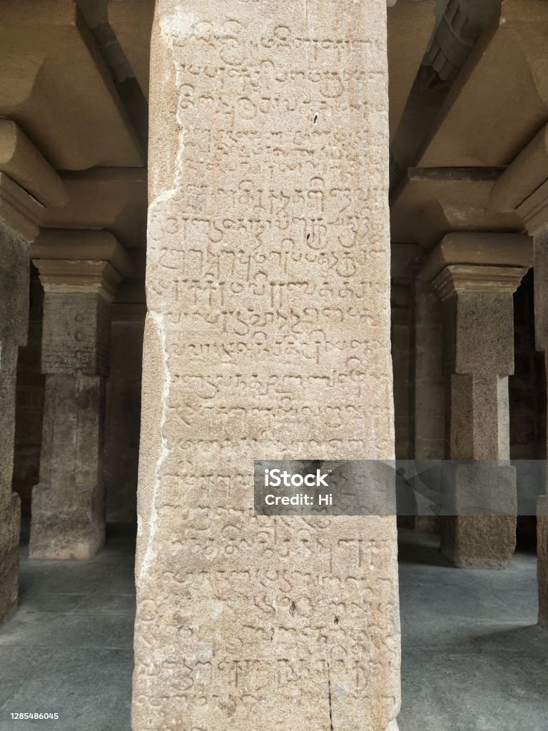

Chalukyan Inscription (<https://www.istockphoto.com/photo/stone-inscription-of-tamil-text-in-ancient-kanchi-kailasanathar-temple-in-gm1285486045-382308005>): purchasable image

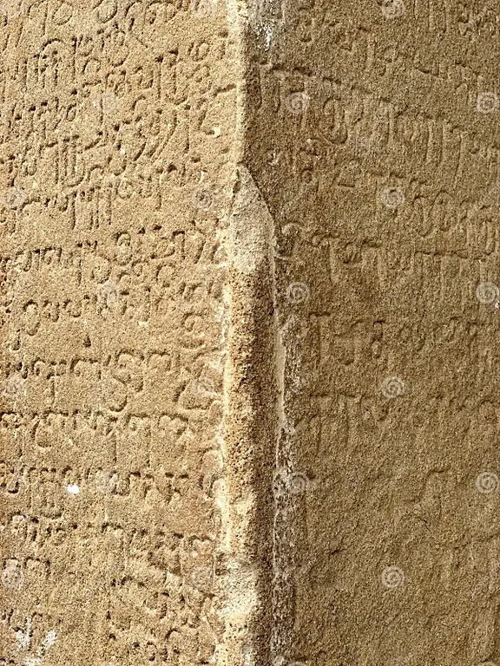

Chalukyan Inscription (<https://www.istockphoto.com/photo/stone-inscription-of-tamil-text-in-ancient-kanchi-kailasanathar-temple-in-gm1285486045-382308005>): purchasable image

1. **The Interpretation Centre**

The Interpretation Centre at Kailasanathar Temple is envisioned as a gateway that invites visitors to delve into the temple's profound layers of meaning. It offers an immersive journey through:

1. Religion & Symbolism: Explore the sacred iconography and spiritual narratives embedded in the temple’s planning, sculptures and carvings. Understand the divine connections, mythological tales, and religious rituals that shape the temple's purpose, offering visitors a deeper appreciation of the site as a living center of devotion.
2. History: Uncover the rich historical backdrop of the Kailasanathar Temple, spanning centuries of political, cultural, and social influences. The centre will chronicle the timeline of the Pallava dynasty, the temple’s founders, as well as highlight the spread of Shaivism under their rule.
3. Art: Delve into the intricate artistic traditions expressed through the temple’s architecture and sculpture. The centre will highlight the temple as a canvas for master craftsmen, where every surface tells a story, from the majestic stone carvings to the fine decorative motifs that demonstrate the high point of Pallava artistic achievement.
4. Architecture: Understand the temple as a monumental achievement in South Indian temple architecture. Visitors will learn about the evolution of Dravidian architectural styles and the temple’s layout, including its use of space, geometry, and sacred alignments, offering insights into the architectural brilliance that made Kailasanathar Temple an enduring symbol of Pallava grandeur.

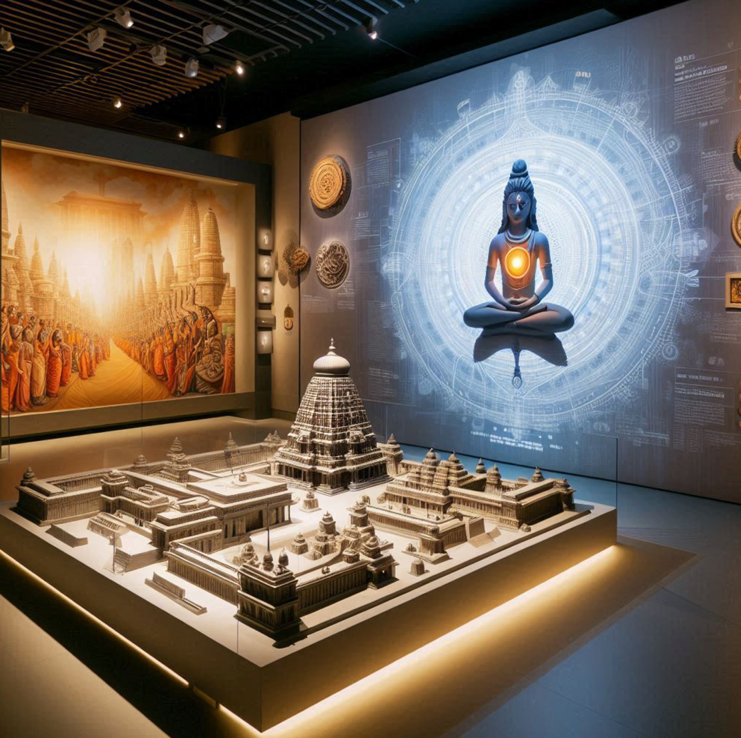

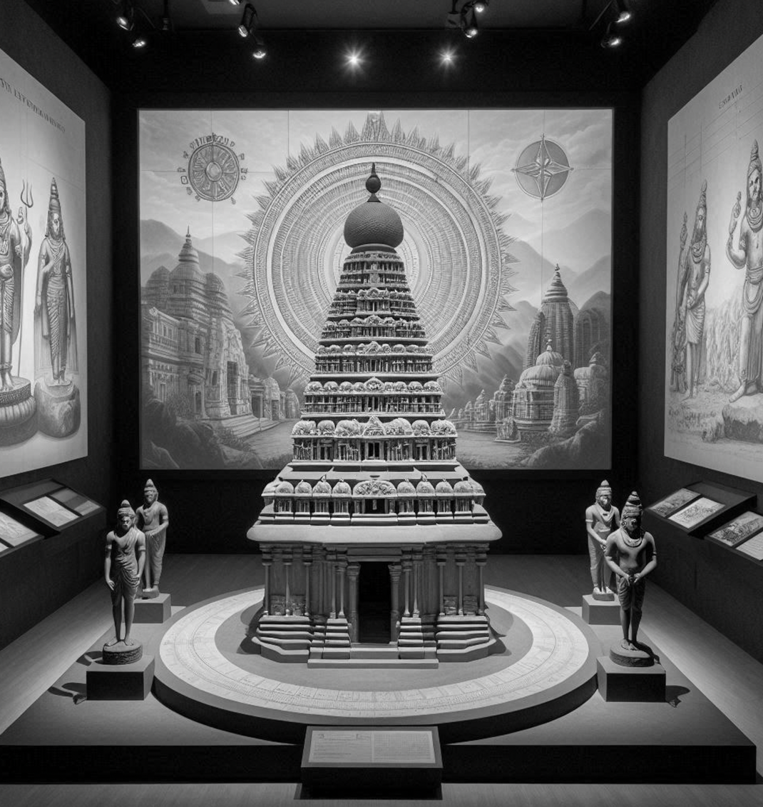

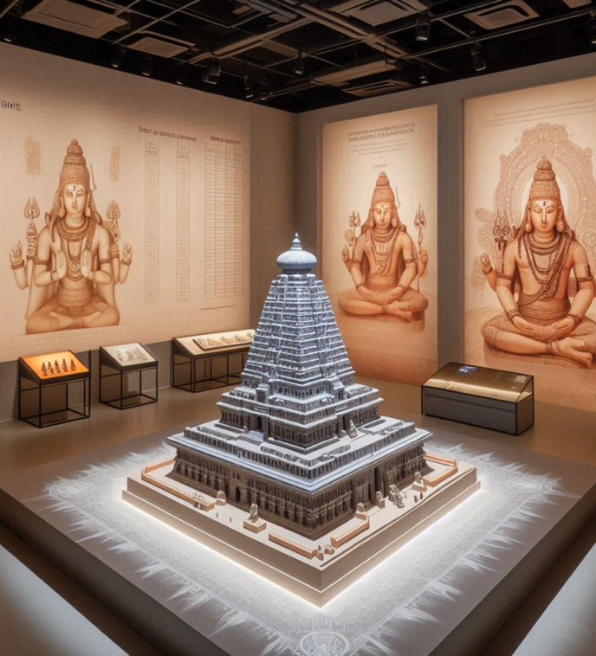

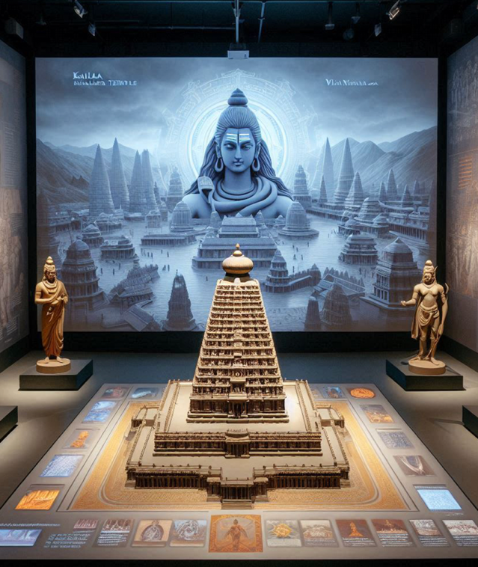

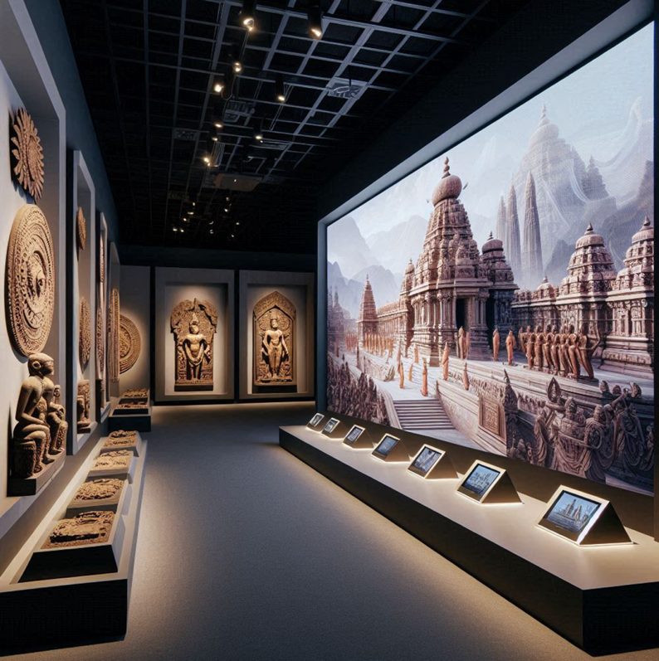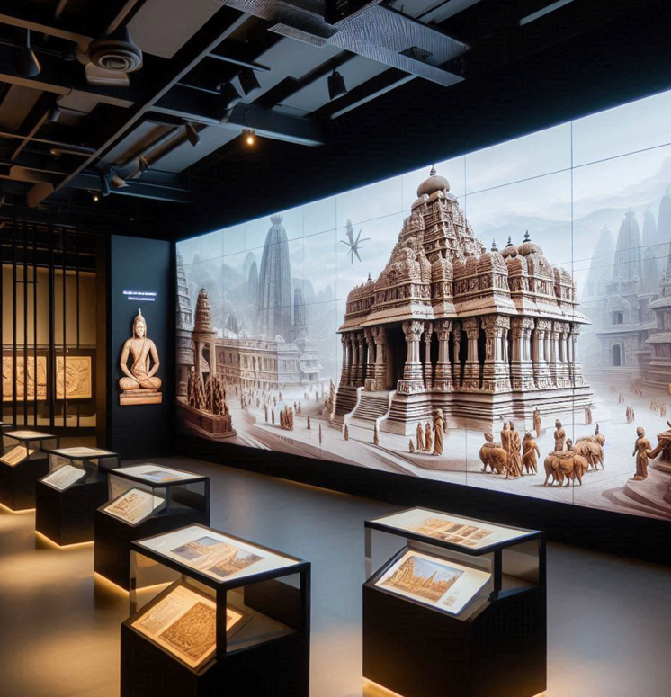

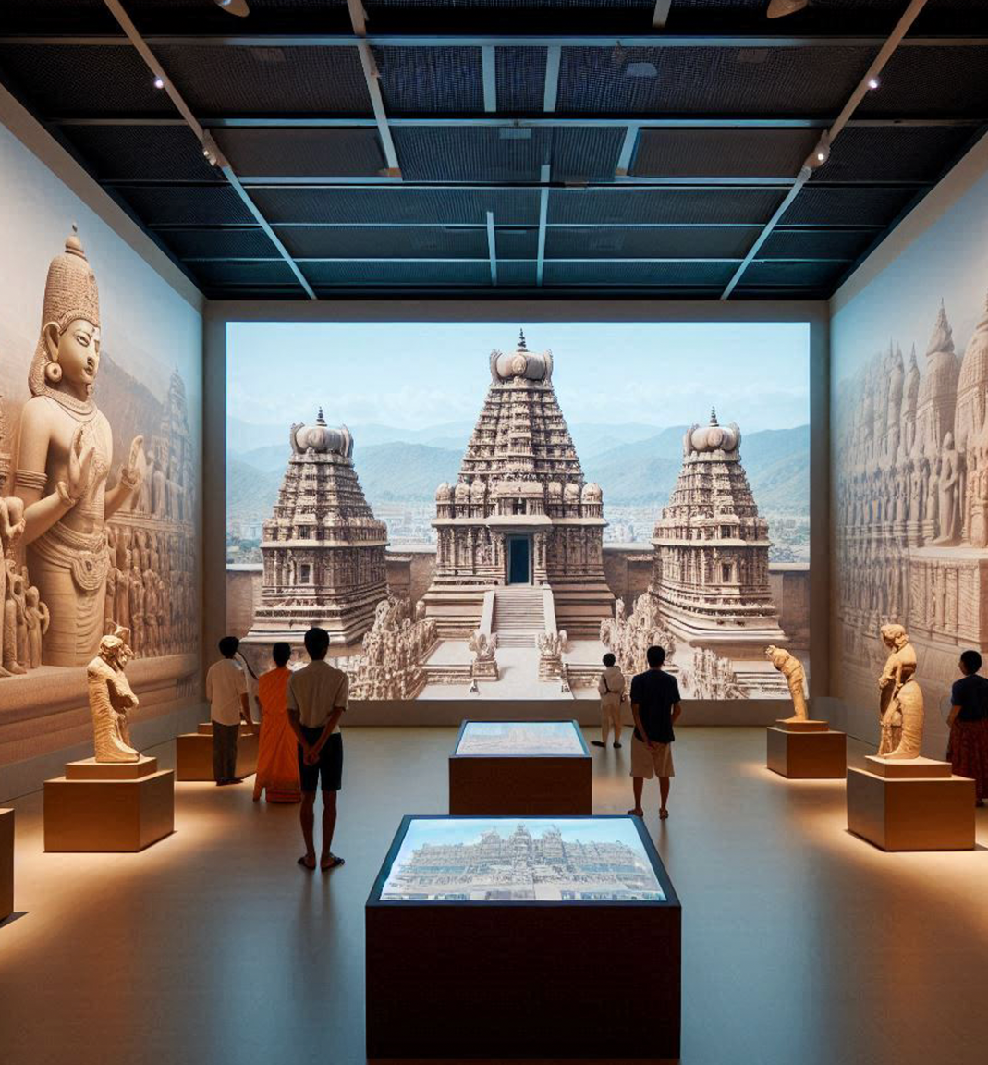

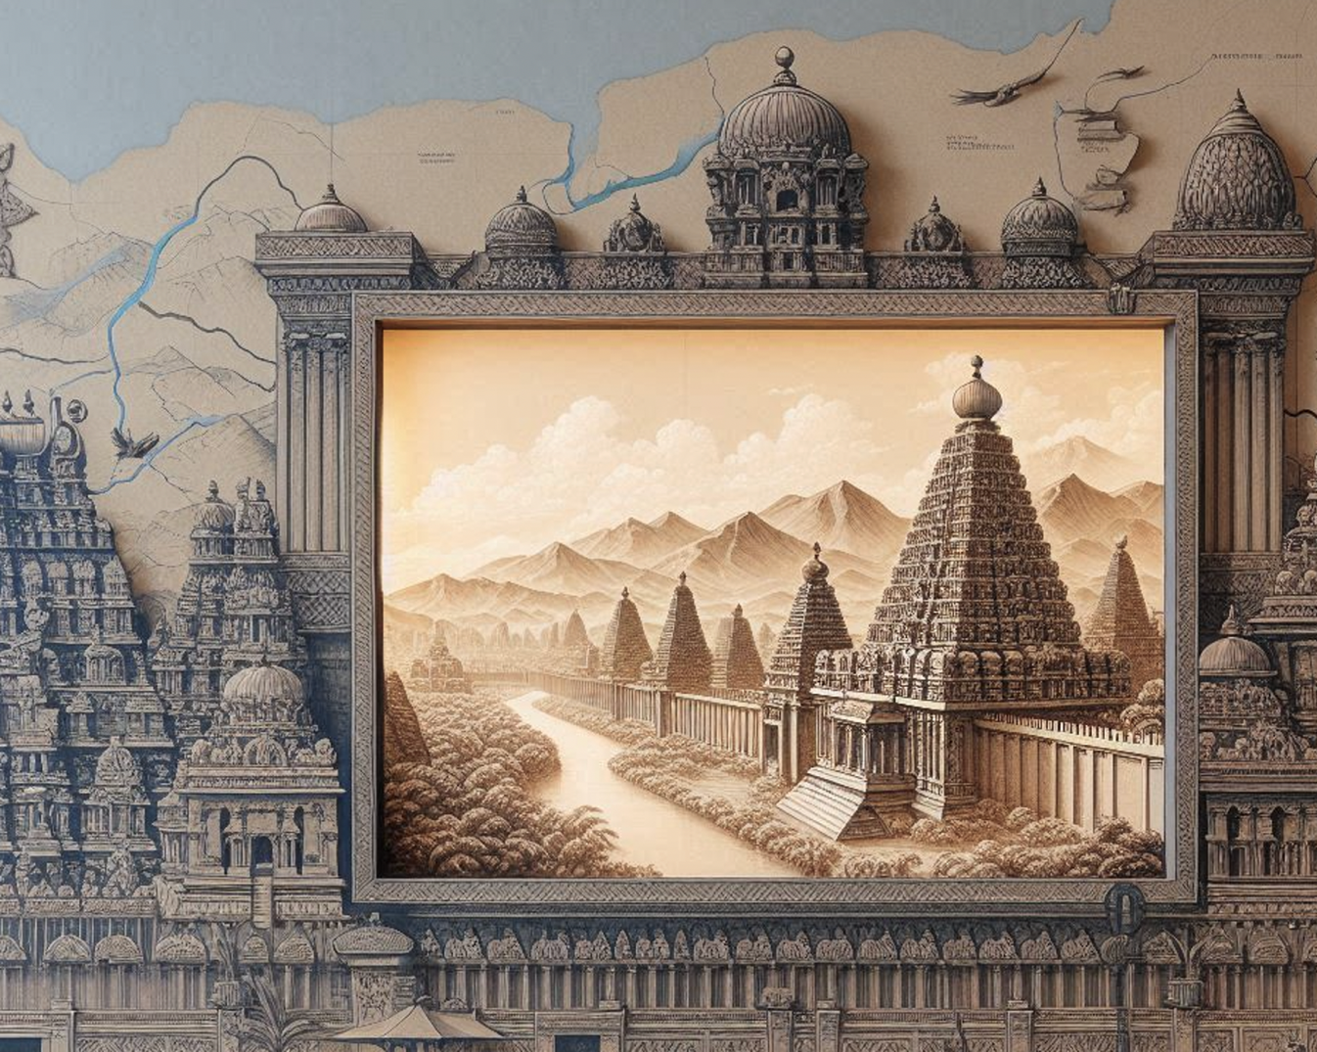

1. **Brief on the Outdoor Museum**

The Outdoor Museum at the Kailasanathar Temple site is proposed as an accessible, immersive experience for visitors by showcasing key sculptures and inscriptions from the temple. This open-air exhibit will enable visitors to engage directly with the temple’s artistic and historical heritage, allowing them to explore intricate carvings, divine iconography, and ancient inscriptions in a way that deepens their connection to the site.

Alongside each display, informative plaques/interpretive panels will provide interpretations, historical context, insights into the significance, and explanations of the craftsmanship behind these remarkable works. Through this, the Outdoor Museum aims to celebrate and preserve the intricate artistry and cultural richness of the Kailasanathar Temple, while ensuring its stories reach a wider audience.

1. **Sources & References**

Adam Hardy, *Indian Temple Architecture: Form and Transformation* – Discusses the evolution of temple architecture in South India and includes references to the role of tanks in temples.

Gopalan R (1928) *History of the Pallavas of Kanchi.* Madras:The University of Madras.

Kanchipuram: The Temple City – Tamilnadu Tourism Web Archive

Kaimal, P. (2021) *Opening Kailasanatha: The Temple in Kanchipuram Revealed in Time and Space*. 1st edition. [Online]. Seattle: University of Washington Press.

Majlis, Brigitte Khan. *La Création d'une Iconographie Śivaïte Narrative: Incarnations du dieu dans les temples pallava construits* – This work focuses on the narrative representation of Shiva’s incarnations in Pallava temples, including detailed analysis of the Kailasanathar Temple.

Nagaswamy, R. (1969) *The Kailasanatha Temple: A Guide.* State Department of Archaeology, Government of Tamil Nadu,

Nagaswamy R.: "The Arts of Tamil Nadu," discussing the iconographic and artistic features of the Kailasanathar Temple and its significance in Pallava art.

Nagaswamy, R. *Masterpieces of South Indian Art* – Provides additional context on Shiva iconography and Pallava architecture.

Nagaswamy, R. "Kailasanathar Temple, Kanchipuram." *The Journal of the Indian History Congress*, vol. 70, 2009, pp. 10-15.

Naraswamy, K. R. *The Architecture of the Temples of the Pallavas*. Abhinav Publications, 1994.

Vedic Books. *Kailasanathar Temple - Temple Purohit*.

Rajarajan, R.K.K.. (2016). *The Iconography of the Kailāsanātha Temple - Seeing beyond the replastered Images and Yoginīs.* Indologica Taurinensia, Torino, Italy. 41-42. 99-148.

Rajwswari D. R. (1988) *The Pallava Sculpture.* Intellectual Publishing House. New Delhi.

Sengupta, A. (2009) *Kailasanatha Temple: The Realm of Immortals,* Agam Kala Prakashan, Delhi

# Stein, Emma Natalya, *All Streets Lead to Temples: Mapping Monumental Histories in Kanchipuram, ca. 8th-12th centuries CE,* Thesis at Yale University

Stein, E. N. (2021) *Constructing Kanchi: City of Infinite Temples*. 1st edition. [Online]. Netherlands: Amsterdam University Press.

The references to V. Ganapathy Sthapathi's *The Building of Kailasanatha: Temple Architecture of Ancient India* are derived from multiple sources discussing the book's contents and themes.

# UNESCO (2018). Temples of Kanchipuram - UNESCO World Heritage Centre. [online] Unesco.org. Available at: https://whc.unesco.org/en/tentativelists/6528/